## AUTOMATIC QUESTION GENERATION

Submitted in partial fulfillment of the requirements of the degree of

Bachelor of Engineering in Computer Engineering By

**ABHISHEK PHALAK (Roll No. 18102A0027) SHUBHANKAR YEVALE (Roll No. 18102A0031) GAURAV MULEY (Roll No. 18102A0038)**

Under the Guidance of

**Prof. Amit Nerurkar**

Department of Computer Engineering



Vidyalankar Institute of Technology Wadala(E), Mumbai-400437

University of Mumbai 2021-22

## CERTIFICATE OF APPROVAL

This is to certify that the project entitled

**“AUTOMATIC QUESTION GENERATION”**

is a bonafide work of

**ABHISHEK PHALAK (Roll No. 18102A0027)**

**SHUBHANKAR YEVALE (Roll No. 18102A0031)**

**GAURAV MULEY (Roll No. 18102A0038)**

submitted to the University of Mumbai in partial fulfillment of the requirement for the award of the degree of

**Undergraduate** in **“COMPUTER ENGINEERING”**.

|  |  |  |
| --- | --- | --- |
| Guide | Head of Department | Principal |
| Prof. Amit Nerurkar | Dr. Sachin Bojewar | Dr.S.A.Patekar |

### Project Report Approval for B. E.

This project report entitled ‘AUTOMATIC QUESTION GENERATION**’** by

1. **Abhishek Phalak (18102A0027)**
2. **Shubhankar Yevale (18102A0031)**
3. **Gaurav Muley (18102A0038)**

is approved for the degree of **Bachelor of Engineering in Computer Engineering.**

Examiners

1.

2.

Date: Place:

### Declaration

I declare that this written submission represents my ideas in my own words and where others' ideas or words have been included, I have adequately cited and referenced the original sources. I also declare that I have adhered to all principles of academic honesty and integrity and have not misrepresented or fabricated or falsified any idea/data/fact/source in my submission. I understand that any violation of the above will be cause for disciplinary action by the Institute and can also evoke penal action from the sources which have thus not been properly cited or from whom proper permission has not been taken when needed.

Name of student Roll No. Signature

1. Abhishek Phalak 18102A0027
2. Shubhankar Yevale 18102A0031
3. Gaurav Muley 18102A0038

Date:

### ACKNOWLEDGMENT

We are honored to present “Automatic Question Generation” as our B.E Final Year Project. We are using this opportunity to express our profound gratitude to our principal “Dr.S.A.Patekar ” for providing us with all proper facilities and support.

We express our deepest gratitude towards our HOD “Dr.Sachin Bojewar” for his valuable and timely advice during the various phases in our project. We would like to thank our project guide “Prof. Amit Nerurkar” for support, patience and faith in our capabilities and for giving us flexibility in terms of working and reporting schedules. Finally, we would like to thank everyone who have helped us directly or indirectly in our project.

We would also like to thank our staff members and lab assistant for permitting us to use computer in the lab as when required. We thank our college for providing us with excellent facilities that helped us to complete and present this project.

Abhishek Phalak

Shubhankar Yevale

Gaurav Muley

### ABSTRACT

It is critical to evaluate an individual's capabilities in order to assess their capabilities. Exams have a vital part in the testing process and, as a result, the questions that must be tested. Framing questions may be a tiresome endeavour at times, necessitating the use of automated question generating. Natural Language Processing may be used to produce questions that are accurate, answered, and efficient (NLP). We can structure questions by accepting and processing information using NLP and different question creation methods. MCQs, fill in the Blanks, WH questions, Crosswords, and a quick synopsis of the supplied material are among the questions created. Before being sent to the AQG, the data is pre-processed. Depending on the supplied content, the questions are verified for contextual relevance and answerability. Automated Question Generation can be beneficial in self-analysis, self-guidance, and other areas.

|  |  |
| --- | --- |
| TABLE OF CONTENTS | |
| **LIST OF FIGURES** | |
| **LIST OF ABBREVIATIONS** | |
| 1. **INTRODUCTION**    1. Introduction    2. Problem Statement    3. Objective | **1** |
| 1. **LITERATURE SURVEY**    1. Survey of Existing / Similar systems | **5** |
| 1. **SYSTEM DESIGN**    1. Proposed System    2. Model Architecture    3. Methodology    4. Hardware and Software Requirements    5. Analysis       1. Process model       2. Feasibility analysis       3. Timeline chart       4. UML diagrams | **13** |
| 1. **SYSTEM IMPLEMENTATION**    1. Implementation : Models and UI development    2. Source codes | **26** |
| **5. RESULTS AND DISCUSSIONS** | **37** |

|  |  |
| --- | --- |
| * 1. Snapshots of results   2. Calculations and discussions | |
| 1. **CONCLUSION AND FUTURE SCOPE**    1. Conclusion    2. Future Scope | **42** |
| **REFERENCES** | **45** |
| **APPENDIX**  Published Papers & respective Certifications | **46** |

###### LIST OF FIGURES

Fig 1: Snapshot of the Proposed System 14

Fig 2: Architecture 15

Fig 3: Dataset Reference 18

Fig 4: Waterfall Model 21

Figure 5: Gantt Chart 24

Figure 6: UML Diagram 25

Fig 7: Results - UI Display 38

Fig 8: Results – Providing Input 39

Fig 9: Results – Prediction of the Final score 39

LIST OF TABLES

Table 1: Survey of Existing Systems 6

Table 2: Description of the Attributes in the dataset 20

Table 3: Timeline Chart 23

Table 4: Values for Evaluation metrics 41

## CHAPTER 1 INTRODUCTION

### INTRODUCTION

In today's society, online learning has become one of the most important aspects of education, allowing students to access learning resources at any time and from any location. Conducting assessments is also important for assessing the student's understanding. The exam curriculum is extensive, but the number of questions to be asked is rather modest; as a result, manually generating questions with the same level of precision becomes laborious. A set of well-crafted questions would aid in determining a student's level of understanding. As a result, utilizing a model to create questions with the highest level of accuracy every time would be beneficial.

The system receives text documents as input from the user and creates questions depending on the text document's various portions and parameters. The system does some pre-processing and looks for words/phrases that might be used as responses to the questions that are created. Based on the context in which they are utilized in the paper, these essential responses would then be used to generate questions. From these replies, the system generates syntactically and semantically valid questions that may be answered in context with the material that the user has supplied. The significant and answerable questions are then utilized to create a self-evaluation quiz that allows the user to assess their grasp of the topic or idea.

### PROBLEM STATEMENT

With the advent of machine learning and natural language processing techniques in education sector, predicting the questions to be generated for a given text has been established as a dependable form of question generation. We focus our research on automatic question generation, which is a tedious task for professors. With this project, we aim to reduce the efforts required by professors to generate varied type of questions. To create a system that accepts a user-supplied text document as input. The system should parse the input text and identify the most important replies. It should ask questions to which the essential answers obtained in the previous stage should be the responses. To test general comprehension of a chapter or topic, format these questions as a Wh Question, fill-in-the-blank, MCQ, or crossword. A transformer model is also used to create a summary of the entered text.

We have gone through various other systems that generate questions based on the input text but these proposed systems generate one type of questions. It is difficult to gauge the overall understanding of a chapter over one type of question. Hence, we propose a system which generates different types of questions in the form of Wh Question, fill-in-the-blank, MCQ, or crossword. Hence, we look forward to propose a model that will consider the dynamicity and efficiently generate questions according to user needs.

### OBJECTIVE

We are proposing a system that will help the professor to generate questions effortlessly and without any hassle. Firstly, the user needs to fill the input fields provided on the webpage. The input fields require the text from which questions are to be generated and number of questions to be generated. Then he/she needs to select the appropriate button according the desired question type. Upon providing all the input fields, the system provides the user with questions in the form of :

* WH Questions
* MCQ
* Fill in the blanks
* Summary
* Crossword

The main objectives of preparing this model are to:

* + To automatically generate questions surrounding the pivotal answer.
  + To conduct a test for the student using the generated questions.
  + To measure overall understanding of a topic using FIB, WH question and crosswords.
  + To summarize the entered text.

## CHAPTER 2 LITERATURE SURVEY

### 2.1. SURVEY OF EXISTING SYSTEMS

|  |  |  |
| --- | --- | --- |
| **Sr.No** | **Authors & Title of Paper** | **Features** |
| **1.** | Putting the Horse Before the Cart: A Generator-Evaluator Framework for Question Generation from Text. Vishwajeet Kumar, Ganesh Ramakrishnan, and Yuan-Fang Li-Published: Sept 2019 | Automatic question generating (QG) is a valuable but difficult task in natural language processing (NLP). Recent neural network-based techniques are at the cutting edge of this challenge. They greatly strengthened them in this study by employing a holistic and unique generator-evaluator architecture that directly optimises objectives that reward semantics and structure. The generator is a sequence-to-sequence model that integrates the structure and semantics of the generated query. The generator anticipates an answer in the passage on which the inquiry can turn. Using the copy and coverage algorithms, it also recognises other contextually relevant (and possibly rare) keywords in the passage that the inquiry must adhere to, without redundantly repeating terms. |
| **2.** | Let’s Ask Again:Reﬁne Network forAutomatic Question Generation - Preksha Nema, Akash Kumar Mohankumar, Mitesh M. Khapra, Balaji Vasan Srinivasan, Balaraman Ravindran - Published: 2019 | In this paper, we focus on the job of Automatic Question Generation (AQG), in which the aim is to generate the equivalent question given a passage and an answer. The produced question should be I grammatically correct (ii) answerable from the passage (iii) specific to the given answer. t do not comply to one or more of the aforementioned criteria. |

|  |  |  |
| --- | --- | --- |
|  |  | We propose the Refine Network (RefNet), which consists of two decoders. The second decoder employs a dual attention network, which focuses on I the original passage and (ii) the question (first draught) created by the first decoder. In effect, it refines the first decoder's inquiry, making it more accurate and full. We test RefNet on three datasets, SQuAD, HOTPOT-QA, and DROP, and find that it outperforms existing state-of-the-art approaches by 7-16% on all of them. Finally, we show that by explicitly rewarding revisions that improve on the corresponding metric during training, we may increase the quality of the second decoder on specific metrics such as fluency and answerability. The code is now available to the public. |
| **3.** | Tejinder Singh, Vishal Singhla, Prateek Bhatia. “Score and winning prediction in cricket through data mining”. | Tejinder Singh, Vishal Singla and Prateek Bhatia aim to predict the score of both the innings of a One-day international cricket match [ODI] and thus predict the winner. The dataset has been collected from espncricinfo website and possesses all the data of matches between 2002 to 2014 for eight teams as mentioned in the related work. Further the data has been analyzed in Weka where it is divided as the training dataset and the testing dataset. The authors have implemented Linear Regression Classifier for the first innings and the Naïve Bayer’s Classification for the second innings. The data of 5 overs span each from first to fifth over uptil 45th to 50th over has been attributed to both the playing teams for both the innings.  Accuracy of Naïve Bayer’s classification starts |

|  |  |  |
| --- | --- | --- |
|  |  | from 68 percent at the initial stage of the innings increasing to 91 percent at the end of the innings. |
| **4.** | D Thenmozi, P Mirunalini, S M Jaisakhti et al. Moneyball – “Data mining on cricket dataset” | D Thenmozi, P Mrinalini, SM Jaisakthi aim to predict the winner of an ongoing IPL match at any instantaneous moment of the event. The authors collected the dataset from the website [‘www.cricsheet.org](http://www.cricsheet.org/)’ and have implemented machine learning algorithms such as ‘Gaussian Naive Bayes’, ‘Support Vector Machine’, ‘K- Nearest Neighbour’ and ‘Random Forest regression’. After filtering the data, they implement the Recursive feature elimination method in order to sort and select the features. Generated models were based on the phases: from 2-overs to 20-overs: in an ongoing match. They analyse the results by considering few factors such as – ‘the number of features selected’, ‘which phase of the match is inputted’, ‘which machine learning technique is used’ and ‘the team considered for prediction’ – and thereafter conclude that random forest regression provided the optimum accuracy for prediction. The overall accuracy in their model is 75.5%. |
| **5.** | A. N Wickramasinghe, Roshan D. Yapa. “Cricket Match Outcome Prediction Using Tweets and  Prediction of the Man of the Match | A N Wickramasinghe and Roshan D. Yapa focus on predicting the man of the match as well as the outcome of that particular cricket match.  The authors extracted around 150000 tweets |

|  |  |  |
| --- | --- | --- |
|  | using Social Network Analysis: Case Study Using IPL Data” | using R studio by accessing twitter API and segregated them into negative and positive ones. 3 models proposed for the prediction were – one based on tweets, the other based on natural parameters and the third based on both tweets and natural parameters. ‘Logistic Regression’, ‘Support Vector Machine’, ‘Random Forest’ and ‘Naïve Bayes’ were the methods used for classification and the logistic regression classifier was used to find out whether there is any relationship between being popular and being elected as the man of the match. They tested all the models using 10 cross validation and later evaluated them on Accuracy, Sensitivity, Specificity and Cohen’s kappa statistic. It was concluded mixed model provided the maximum accuracy of 89% while the natural parameter-based model was 83% accurate. |
| **6.** | Aminul Islam Anik, Sakif Yeaser,  A.G.M Imam Hossain, Amitabha Chakrabarty. “Player’s Performance Prediction in ODI Cricket Using Machine Learning Algorithms”. | Aminul Islam Anik, Sakif yeaser, AG M Imam Hossain and Amitabha Chakrabarty propose a model to predict a player`s performance in an upcoming match by studying their past data. The authors focus on the players of Bangladesh National Cricket team and have collected the data from howstat and espncricinfo websites. They preprocessed the dataset and used Scikit- learn package in order to select 5 important features from it. Thereafter two methods used  for feature selection were – ‘Recursive Feature |

|  |  |  |
| --- | --- | --- |
|  |  | Elimination’ and ‘Feature Selection Using Univariate Selection’. They eliminated uncertain features such as 4s and 6s hit by a batsman in an upcoming match which cannot be predicted. ‘Linear regression’, ‘Support Vector Machine (SVM) with Linear and Polynomial Kernel’ and ‘Processing text data with Bag of words concept’ were the three techniques used for predicting the performance of any selected player. The model provided up to the mark accuracy for all the players and the highest accuracy of about 92% was achieved while predicting Tamim Iqbal`s batting performance  in his upcoming match. |
| **7.** | Siyamalan Vanimannan, Mogan Kausik. “Convolutional Neural Network and Feature Encoding for Predicting the Outcome of Cricket Matches” | Siyamalan Manivannan and Mogan Kaushik have put forward two approaches – one is feature encoding and the other is Convolutional Neural Network (CNN) for predicting the outcome of the cricket match. The author sets up his proposed approach with the baseline approach. They collected the data from espncricinfo website using the python wrapper. In this paper, data augmentation is applied to training and testing dataset and normalized the final feature vector before giving it to linear SVM classifier. The authors applied clustering method during the feature encoding approach and used the player-category similarity as a weighted distance measure in order to determine the team-category relationship. While applying  the CNN they connected the input nodes and the |

|  |  |  |
| --- | --- | --- |
|  |  | hidden nodes followed by implementing the CNN property of weight sharing. The accuracy of the model was over 70 percent using shallow  CNN by training just 4000 parameters. |
| **8.** | Manuka Maduranga Hatharasinghe, Guhanathan Poravi. “Data Mining and Machine Learning in Cricket Match Outcome Prediction: Missing Links”. Issued March 2020. DOI 10.1109/I2CT45611.2019.90  33698. | Manuka Madhuranga Hatharasinghe and Guhanathan Poravi aim to use computer intelligence to predict cricket match outcomes and are studying the related works for the same. This paper is a result of an ongoing research. The authors point out match stimulation, team selection and player performance analysis as the three main domains to improvise the accuracy for prediction. The two main approaches that they followed were the use of historical cricket data and the collective knowledge. In usage of historical data, classification using team and categorical data done by naïve Bayer’s algorithm gave the maximum accuracy. Moreover, they discussed the team composition approach that provided the highest accuracy by using the historical data. Analyzing the existing works by relating the data used to that of the raw features, engineering features and the categorical features helped the authors conclude that the collective knowledge approach provided an accuracy of whooping 87%. |
| **9.** | Jalaz Kumar, Rajeev Kumar, Pushpender Kumar. “Outcome Prediction of ODI Cricket Matches  using Decision Trees and MLP | Jalaz Kumar, Rajeev Kumar and Pushpender Kumar in use Decision Trees and Multilayer Perceptron Network to analyze the outcome of a  cricket match. The authors have considered |

|  |  |  |
| --- | --- | --- |
|  | Networks”. Accessed November 2021. DOI  10.1109/ICSCCC.2018.8703301 | various pre-game and in-game attributes for the same. The data has been extracted from EspnCricinfo website by running a scraping script in a justified manner sending requests at every second. After preprocessing the data, they applied Decision tree and Multilayer Percepton Network classification techniques to it. In MLP, all vectors comprising the training samples were held in X & the target values for respective training samples were held in Y. In Decision tree technique the subsets were split and they used the impurity function for determining impurity followed by partioning the subsets until the maximum allowable depth was reached. After analyzing all the factors that strive to affect the flow of a cricket game, they compare the simulation results such as accuracy value and precision value. That helped the authors to conclude that the Multilayer Perceptron Network approach was more accurate than Decision technique displaying an accuracy of 0.576 and 0.551 respectively. |

Table 1: Survey of Existing Systems

## CHAPTER 3 SYSTEM DESIGN

### PROPOSED SYSTEM

We propose a system which will help users to generate different types of questions such as MCQ, Fill in the blanks, crossword and Wh- question. We also provide a short summary of the text given as input. The components of the system are as follows –

1. **Input:**

The user has to input the text for which questions have to be generated in the UI. The website is integrated with flask to analyze the text and carry out machine learning operations. According to user needs, we generate the number of questions based on the input given by the user.

1. **Preprocessing:**

Various preprocessing techniques used during question generation are –

1.POS Tagging – Part Of Speech(POS) Tagging is a process in Natural Language processing which categorizes the words into their corresponding part of speech. Eg. Verb, adjective, noun etc. For POS tagging we use pos_tag function from NLTK library which returns the pos tag of word.

2.NER Tagging - NER tagging categorizes a named entity into defined classes such as location, person, organization etc. NER tagging is very crucial in generating rule based wh-questions as depending upon the entity questions can be framed.

3.Tokenization – Tokenization is the process of breaking strings into small tokens. The tokens can be a substring or a word. We have used both sentence tokenizer and word tokenizer in question generation.

1. **Question Generation**

After the user inputs the text and number of questions to be formed, the text cleaning and preprocessing is performed. The Fill in the blank generator is trained on SQUAD v1 dataset which finds the pivotal answers and replaces it with a blank. The answer choices are also then sent to a crossword generator to make a crossword where the answers are hidden and clues are provided to find the answers. For MCQ, wrong answers are generated by finding the words which have very similar global word representation. The summary generator provides a short summary to give a brief description about the text.

###### MODEL ARCHITECTURE

Fig 1: Architecture

###### HARDWARE AND SOFTWARE REQUIREMENTS

**Hardware used**:

* + **Laptop** : 8 GB RAM, 1 GB free memory, i7 Core Processor, Windows 10

**Software used:**

* + **Google colab** : To program the Machine Learning Code
  + **Flask** : Used for development of the Webpage
  + **Visual Studio Code** : Used for Python Programming

**Dependencies:**

* + **Numpy** : The name “Numpy” stands for “Numerical Python”. It is the commonly used library. It is a popular machine learning library that supports large matrices and multi- dimensional data. It consists of in-built mathematical functions for easy computations. Even libraries like TensorFlow use Numpy internally to perform several operations on tensors. Array Interface is one of the key features of this library.
  + **Pandas** : Pandas are an important library for data scientists. It is an open-source machine learning library that provides flexible high-level data structures and a variety of analysis tools. It eases data analysis, data manipulation, and cleaning of data. Pandas support operations like Sorting, Re-indexing, Iteration, Concatenation, Conversion of data, Visualizations, Aggregations, etc.
  + **Matplotlib** : This library is responsible for plotting numerical data. And that’s why it is used in data analysis. It is also an open-source library and plots high-defined figures like pie charts, histograms, scatterplots, graphs, etc.
  + **Pickle** : Python pickle module is used for serializing and de-serializing a Python object structure. Any object in Python can be pickled so that it can be saved on disk.
  + **Seaborn** : Seaborn is a library for making statistical graphics in Python. It builds on top of matplotlib and integrates closely with pandas data structures. Seaborn helps you explore and understand your data.
  + **Scikit-learn** : It is the most useful and robust library for machine learning in Python. It provides a selection of efficient tools for machine learning and statistical modeling including classification, regression, clustering and dimensionality reduction via a consistence interface in Python.

###### METHODOLOGY

**CROSSWORD :**

Crossword generation is an extension of Fill in the Blanks generation. The clues required to find answers in the crossword are the Fill in the blanks questions which are generated using ML and NLP techniques as stated earlier. The answers are hidden by the crossword which can be oriented in any of these directions i.e horizontal, vertical or diagonal. The crossword is basically a 15 X 15 matrix made up of 2-Dimensional list. The spaces in the matrix other than the answers are filled with random alphabets. The process of crossword generation and placing the word in the 2-dimensional matrix with different orientation is extremely random and hence it is better than many rule based crossword generation algorithms.

We have initialized the 15 x 15 matrix by zeros. We have stored the answers in a list. For every answer which is a word, we split the word into individual letters. We have created three functions to place a word in different orientations. Top_bottom function for vertical alignment of the word, Left_right function for horizontal and Diagonal function for slant alignment of the word. The algorithm generates a random number between 1 to 3 using randint() function which in turn results in selecting a random function out of the three functions to place a word. For example, if the random number generated is 1, then it will select the top_bottom() function, if the number generated is 2, then it will select the diagonal() function and so on. Once the function is decided by the random number generation, the function will keep on trying to fit the word in the same orientation as defined by the function until the word fits in the crossword.

The algorithm of all three functions work in similar fashion, except the orientational changes. When a list of word splitted into alphabets is passed to the function, it generates two random numbers. The two numbers combined give a random location of a coordinate in the 2-D space. The algorithm will try to fit the word with the location of the starting letter mentioned by the random coordinate. The function will check whether each and every element is either zero or the required alphabet. If for all the letters the condition is satisfied then the function will place the word. Else it will again find another set of random coordinates and will try to check whether the word can be placed starting with those coordinates. We also have imposed restrictions on the generation of random numbers so as to avoid index out of bound error. Once all the words (answers) are placed in the 2-D matrix, we replace the blank spaces by random alphabets.

Algorithm top_bottom(array, matrix)

// array is the list of alphabets which is created by splitting answer into individual letters. Matrix is 2-Dimensional list in which crossword will be generated. //

1. Start

2. For each I in range(0,225)

{

3. Initialize variable counter to zero

4. Generate two random numbers a(between 1 to (15-length)) and b(between 1 to 15)

5. For each x in range(0, length(word))

{

6. if matrix[(a+x)][b] == 0 or matrix[(a+x)][b] array[x]

{

7. Increment the counter by 1

}

}

8. If counter == length

{

9. for j in range(0, length(word))

{

10. matrix[(a+j)][b] = array[j]

11. return

}

}

}

12. End

We also generate the answer matrix wherein we capitalize the answers and rest all letters are small letters which helps users to clearly figure out where the answers are. The answer word can also be in entangled form. For example, if a word ‘sweet’ is placed and the next word to be placed is train, then the word train can be placed below letter ‘t’ of word ‘sweet’. The main feature of this crossword is its dynamicity. As the orientation of the word chosen is random along with the location chosen to place the word is also random, every time the user gets a different crossword for the same text as input. Hence different crosswords for the same input can be created. Also, the number of answers which are to be hidden in the crossword can be defined by the user. Accordingly, the system generates Fill in the blanks as clues and hides the words in the crossword depending upon the number of questions the user wants to generate.

**Fill in the blanks & MCQ generation:**

For Fill the blanks and MCQ generation, the dataset that we used is SQuAD v1[13] dataset (Stanford Question Answering Dataset). The dataset contains around 21000 paragraphs and 100000 questions. We also extracted the sentences from paragraphs wherein the answers of the question generated lies. We removed all stopwords to be considered for training to find pivotal answers. All the words from paragraphs are taken except the stopwords and features are generated for training. We used POS and NER tagging on all the words to generate features NER tag and POS tag. We have also added features like DEP tag and shape. The most important feature is the ‘Answer’ feature which is a binary column which represents whether the word is the answer or not. With all these features we trained the data on the Naïve Bayes model of the scikit-learn package because Naïve Bayes gives the probability of each word which will help us to decide the pivotal answer. After the model is trained, we save the model so that later it can be used for predicting pivotal answers.

The user should provide the number of questions to be generated. The text given by input is broken into sentences and we preprocess the input. The preprocessed input is then passed to the model to predict the pivotal answer. The word with maximum probability of being a pivotal answer is then replaced by a blank space.

To generate MCQ, it is similar to Fill in the blanks, just we have to provide 3 wrong choices along with answers. So, to generate wrong answers we used a pretrained model of GloVe word-embeddings [14] (Global Vectors for Word Representation) and cosine similarity. GloVe was used to create vector representation for words and cosine similarity was used to measure the similarity between the two vectors. These correct answers were later passed to the crossword generation algorithm to generate crosswords.

**WH QUESTION Generation:**

We used a rule-based approach to generate Wh questions because the sentence formation differs from the input sentence. The preprocessing of the the input text is done as follows –

1. Tokenize into sentences.

2.Remove full stop.

3.Capitalize single alphabet ‘I’ as it is correctly recognized by parser in capital form.

4.Make the first letter lowercase.

This type of algorithm is most suitable for declarative/assertive sentences. To find nouns, we used POS tagging and then to classify into named entities we probability of each word which will help us to decide the pivotal answer. As every sentence in the text cannot be used to frame questions, there arises a need to rank the sentences. So, to rank the sentences, we have used a Text rank algorithm to filter out the important sentences. POS and NER tagging is used to determine the parts of speech and named entity. The two main important aspects which helps in framing wh questions are –

Auxiliary verb – Auxiliary verb conveys information about tense, mood or person. It provides support to the main verb.

Discourse markers – A discourse marker plays a very important role in knowing the direction of a conversation. Mostly the later part of the sentence after the discourse marker is the answer to the previous part. For such sentences, the question type becomes defined. eg. because, as a result, although etc.

We have used three different algorithms for generation of Wh questions which differ in rules to generate the question and depend on the type of sentence.

**NER Based Algorithm** : We have used three different algorithms for generation of Wh questions which differ in rules to generate the question and depend on the type of sentence used NER tagging. The NER tagging tags the word into predefined categories. For example, India is tagged as GEO which means it represents a geographical location, Google is tagged as ORG which means it represents an organization. For such tags, the Wh question to be framed is already determined by the rules. For a location or place, word ‘where’ will be used to generate a Wh question whereas for a time entity, ‘when’ will be used to generate a Wh question. After identifying the Wh question word to be used, we need to transform the sentence along with ensuring semantic and syntactic correctness which is according to the rules defined in the algorithm. If the named entity is found at the start of the sentence, we replace the entity with the corresponding Wh question, if not found we will have to look after the first non-auxiliary verb. If it turns out to be a noun then discard it else keep it in the question part and rearrange the question part. Finally, the Wh word is attached in the beginning and a question mark is attached at the end.

**Discourse marker based algorithm:**

As discussed earlier, sentences with discourse markers can be easily transformed into Wh questions. We have assigned wh question word for every discourse marker. Using NER and POS tagging, find if the auxiliary verb exists. If it exists, then tokenize the part of the sentence before the discourse marker. If the tags indicate that the sentence is in first person, word ‘you’ will be appended to the question part after the Wh-word as defined by the discourse marker rules along with the verb ‘were’. If it is not in first person, then the auxiliary word would be appended after the Wh-word. If there is no auxiliary verb present in the sentence then the auxiliary verb will be in the form ‘do’ i.e., do, did, does etc and using lemmatization we stem the present verb of the sentence. We have created rules to determine which form of do will is required depending upon the combination of noun and verb. For example, if NN/NNP and VBN combination occurs, then the aux verb will be ‘did’, for NN/NNP and VBZ we use ‘does’ and so on. The aux verb is attached to the question part with the Wh-word at the start and question mark at the end to generate a question.

**Non Discourse marker based algorithm:**

Assertive or declarative sentences which do not have any discourse marker comes under this category. Such sentences are usually Yes or No sentences. Here there is no need for the Wh-word, we simply find the auxiliary verb and attach it to the beginning. The rest processing and transformation of the sentences is done exactly the same as the discourse marker algorithm. Finally, a question mark is added at the end of the generated question.

**Summary Generation :**

Summary is a collection of main points which gives you the idea of the whole text in very few words. It becomes easy for users and saves time. For summary generation, we used the T5 transformer model [15]. Transformer is basically a deep learning model which can transform one sentence to another with the help of encoder and decoders. We have used the ‘t5-large’ model with min-length parameter as 50 and max-length parameter as 200. Percentage of text formed as summary (i.e. number of words in summary * 100/ number of words in text) is close to 30 percent which means there is 70 percent reduction in the size of the text while converting into summary

### ANALYSIS

###### PROCESS MODEL

We intend to use the Waterfall Model in the development of our project. The reasons for using this model in our project are given below.

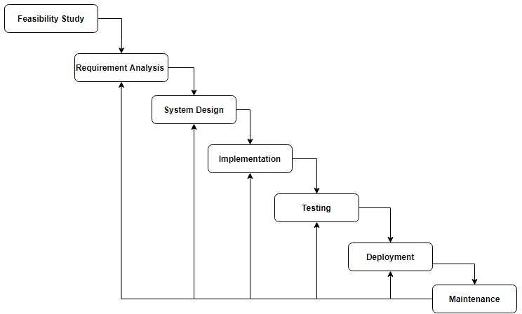

Fig 4: Waterfall Model

* + In waterfall, development of one phase starts only when the previous phase is complete. Because of this nature, each phase of the waterfall model is quite precise well defined. Since the phases fall from a higher level to lower level, like a waterfall, it is named as the waterfall model.
  + Since the requirements are stable and not changing frequently, the Waterfall Model is best suited for the project.
  + It enables the monitoring and departmentalization. A timeline can be set with deadlines for each development step, and a product can proceed through the development process model phases one by one.
  + The waterfall model progresses through easily understandable and explainable phases and thus it is easy to use.
  + It is easy to manage due to the rigidity of the model – each phase has specific deliverables and a review process.
  + Suited for smaller projects where requirements are well defined also Project is completely dependent on project team with minimum client intervention.
  + All the requirements are documented beforehand and Any changes in the system is made during the process of the development.

In this model, phases are processed and completed one at a time and they do not overlap.

###### FEASIBILITY ANALYSIS

* **Technical Feasibility**: Technical feasibility focuses on the technical resources (software and hardware) available to the organization and also helps to determine whether the technical team is capable of converting the ideas into working systems. The software required for our project are mainly open-source and readily available (i.e. Google colab, Python, sklearn, T-5 transformer etc.). No extra hardware is in use for our project except the laptop. Some specifics can be uncovered in detail during implementation.
* **Economic Feasibility**: This assessment typically involves a cost/ benefits analysis of the project. The project will be developed in minimal cost as most of the software required are open-source hence does not involve any upfront cost, the main cost incurred will be of the computer system.
* **Legal Feasibility:** This assessment investigates whether any aspect of the proposed project conflicts with legal requirements like zoning laws, data protection acts, or social media laws. The project does not involve any legal concerns since all the licenses and laws will be respected and included in the project.
* **Operational Feasibility**: This assessment involves undertaking a study to analyze and determine whether—and how well—the organization’s needs can be met by completing the project. The main objective of this project is to generate varied types of questions according to user needs and with minimal human intervention.
* **Resource Feasibility:** The number of people working for the project and the technical resources provided are deemed to be of adequate nature after due analysis and hence the resource feasibility for the project is good.

###### TIMELINE CHART

|  |  |  |  |
| --- | --- | --- | --- |
| **Task Name** | **Start Date** | **End Date** | **Duration (Days)** |
| Analysis | 01-Mar-21 | 30-Apr-21 | 60 |
| Requirements | 01-May-21 | 30-Jun-21 | 60 |
| Design | 01-Jul-21 | 15-Aug-21 | 45 |
| Development: ML Model | 16-Aug-21 | 15-Oct-21 | 60 |
| Development: User Interface | 16-Oct-21 | 30-Nov-21 | 45 |
| Testing & Integration | 01-Dec-21 | 15-Dec-21 | 15 |
| Final Documentation | 15-Mar-22 | 31-Mar-22 | 15 |

Table 3: Timeline Chart

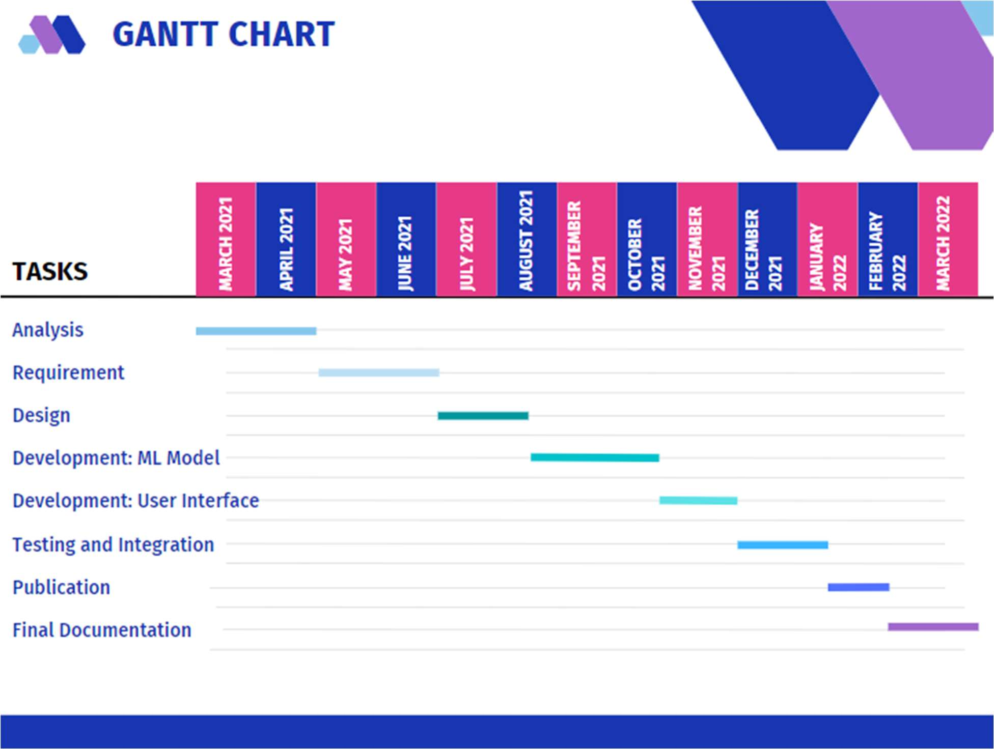

Figure 5: Gantt Chart

###### UML DIAGRAMS

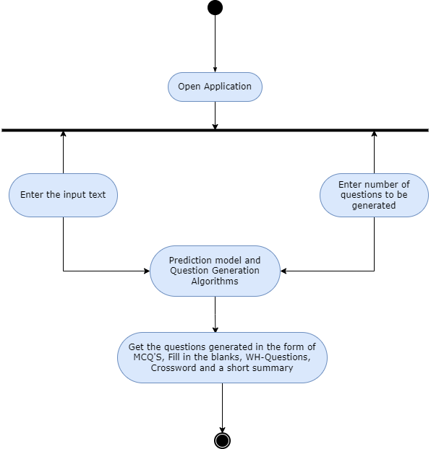

Figure 6 : UML diagram

## CHAPTER 4 SYSTEM IMPLEMENTATION

### IMPLEMENTATION: MODELS & UI

DEVELOPMENT

* **Models:**

1. **Naïve Bayes :**

Naïve Bayes algorithm is a supervised learning algorithm, which is based on Bayes theorem and used for solving classification problems.

It is mainly used in text classification that includes a high-dimensional training dataset.

Naïve Bayes Classifier is one of the simple and most effective Classification algorithms which helps in building the fast machine learning models that can make quick predictions.

It is a probabilistic classifier, which means it predicts on the basis of the probability of an object.

Some popular examples of Naïve Bayes Algorithm are spam filtration, Sentimental analysis, and classifying articles.

Bayes' theorem is also known as Bayes' Rule or Bayes' law, which is used to determine the probability of a hypothesis with prior knowledge. It depends on the conditional probability.

The formula for Bayes' theorem is given as:

P(A|B)= P(B|A) P(A)/P(B)

P(A|B) is Posterior probability: Probability of hypothesis A on the observed event B.

P(B|A) is Likelihood probability: Probability of the evidence given that the probability of a hypothesis is true.

* **UI Development :**

In this project, Flask framework has been used for the UI development. The main web page of the project takes the required inputs from the user in order to generate questions. The user inputs required are the text from which questions have to be generated and the number of questions to be generated. Once the user inputs these fields, the text is preprocessed, trained on machine learning models and it is given to respective question generation algorithms. The generated questions are displayed on website in four different modals wherein user clicks on the desired button and a pop up appears where the desired form of questions are displayed, all the four type of questions are generated and displayed simultaneously on the web page.

### SOURCE CODES

**ALGORITHM :**

**Crossword:**

Algorithm top_bottom(array, matrix)

// array is the list of alphabets which is created by splitting answer into individual letters. Matrix is 2-Dimensional list in which crossword will be generated. //

1. Start

2. For each I in range(0,225)

{

3. Initialize variable counter to zero

4. Generate two random numbers a(between 1 to (15-length)) and b(between 1 to 15)

5. For each x in range(0, length(word))

{

6. if matrix[(a+x)][b] == 0 or matrix[(a+x)][b] array[x]

{

7. Increment the counter by 1

}

}

8. If counter == length

{

9. for j in range(0, length(word))

{

10. matrix[(a+j)][b] = array[j]

11. return

}

}

}

12. End

**MCQ:**

1. Take input from user
2. Preprocess the text.
3. Generate features for SQUAD V1 dataset.
4. Train the model using Naïve bayes algorithm.
5. Predict pivotal answers using the trained model.
6. Using word embeddings and cosine similarities generate wrong answers.
7. Replace the pivotal answers by blank.

**WH Questions:**

1. Take input from user.
2. Capitalize I as it is correctly recognized by parsers.
3. Tokenize the data into sentences.
4. Remove fullstop.
5. For NER based algorithm, use NER tagging for getting named entities and based on named entities we generate WH Questions.
6. For discourse marker based algorithm, for a particular discourse marker generate questions according to the predefined rules in the code and auxiliary verb.
7. For non discourse marker based algorithm, we find the auxiliary verb and attach it to the beginning of the sentence.The rest preprocessing and transformation of sentences into WH Questions is done similar to discourse marker based algorithm to form yes-no sentences.

##### UI CODE:

# Importing essential libraries

from flask import Flask, render_template, request import pickle

import numpy as np

# Load the Random Forest CLassifier model filename = 'first-innings-score-lr-model.pkl' regressor = pickle.load(open(filename, 'rb'))

app = Flask( name )

@app.route('/') def home():

return render_template('index.html')

@app.route('/predict', methods=['POST']) def predict():

temp_array = list()

if request.method == 'POST':

batting_team = request.form['batting-team'] if batting_team == 'Chennai Super Kings':

temp_array = temp_array + [1,0,0,0,0,0,0,0] elif batting_team == 'Delhi Daredevils':

temp_array = temp_array + [0,1,0,0,0,0,0,0] elif batting_team == 'Kings XI Punjab':

temp_array = temp_array + [0,0,1,0,0,0,0,0] elif batting_team == 'Kolkata Knight Riders':

temp_array = temp_array + [0,0,0,1,0,0,0,0] elif batting_team == 'Mumbai Indians':

temp_array = temp_array + [0,0,0,0,1,0,0,0] elif batting_team == 'Rajasthan Royals':

temp_array = temp_array + [0,0,0,0,0,1,0,0]

elif batting_team == 'Royal Challengers Bangalore': temp_array = temp_array + [0,0,0,0,0,0,1,0]

elif batting_team == 'Sunrisers Hyderabad': temp_array = temp_array + [0,0,0,0,0,0,0,1]

bowling_team = request.form['bowling-team'] if bowling_team == 'Chennai Super Kings':

temp_array = temp_array + [1,0,0,0,0,0,0,0] elif bowling_team == 'Delhi Daredevils':

temp_array = temp_array + [0,1,0,0,0,0,0,0] elif bowling_team == 'Kings XI Punjab':

temp_array = temp_array + [0,0,1,0,0,0,0,0] elif bowling_team == 'Kolkata Knight Riders': temp_array = temp_array + [0,0,0,1,0,0,0,0]

elif bowling_team == 'Mumbai Indians': temp_array = temp_array + [0,0,0,0,1,0,0,0]

elif bowling_team == 'Rajasthan Royals': temp_array = temp_array + [0,0,0,0,0,1,0,0]

elif bowling_team == 'Royal Challengers Bangalore': temp_array = temp_array + [0,0,0,0,0,0,1,0]

elif bowling_team == 'Sunrisers Hyderabad': temp_array = temp_array + [0,0,0,0,0,0,0,1]

overs = float(request.form['overs']) runs = int(request.form['runs']) wickets = int(request.form['wickets'])

runs_in_prev_5 = int(request.form['runs_in_prev_5']) wickets_in_prev_5 = int(request.form['wickets_in_prev_5'])

temp_array = temp_array + [overs, runs, wickets, runs_in_prev_5, wickets_in_prev_5] data = np.array([temp_array])

my_prediction = int(regressor.predict(data)[0])

return render_template('result.html', lower_limit = my_prediction-10, upper_limit = my_prediction+5)

if name == ' main ': app.run(debug=True)

## CHAPTER 5 RESULTS AND DISCUSSIONS

### SNAPSHOTS OF RESULTS

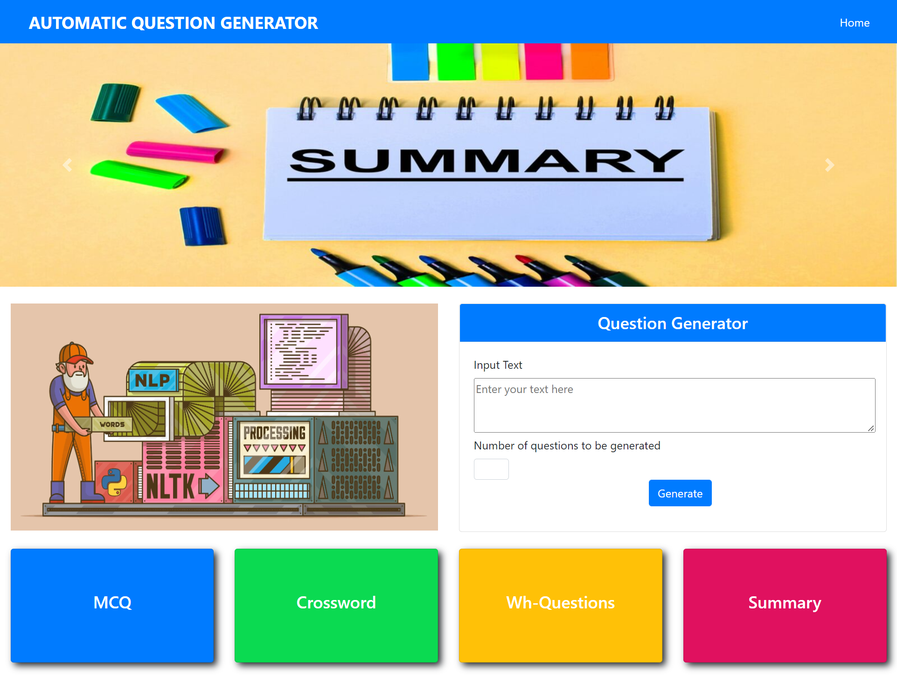

Fig 7: Results: UI Display

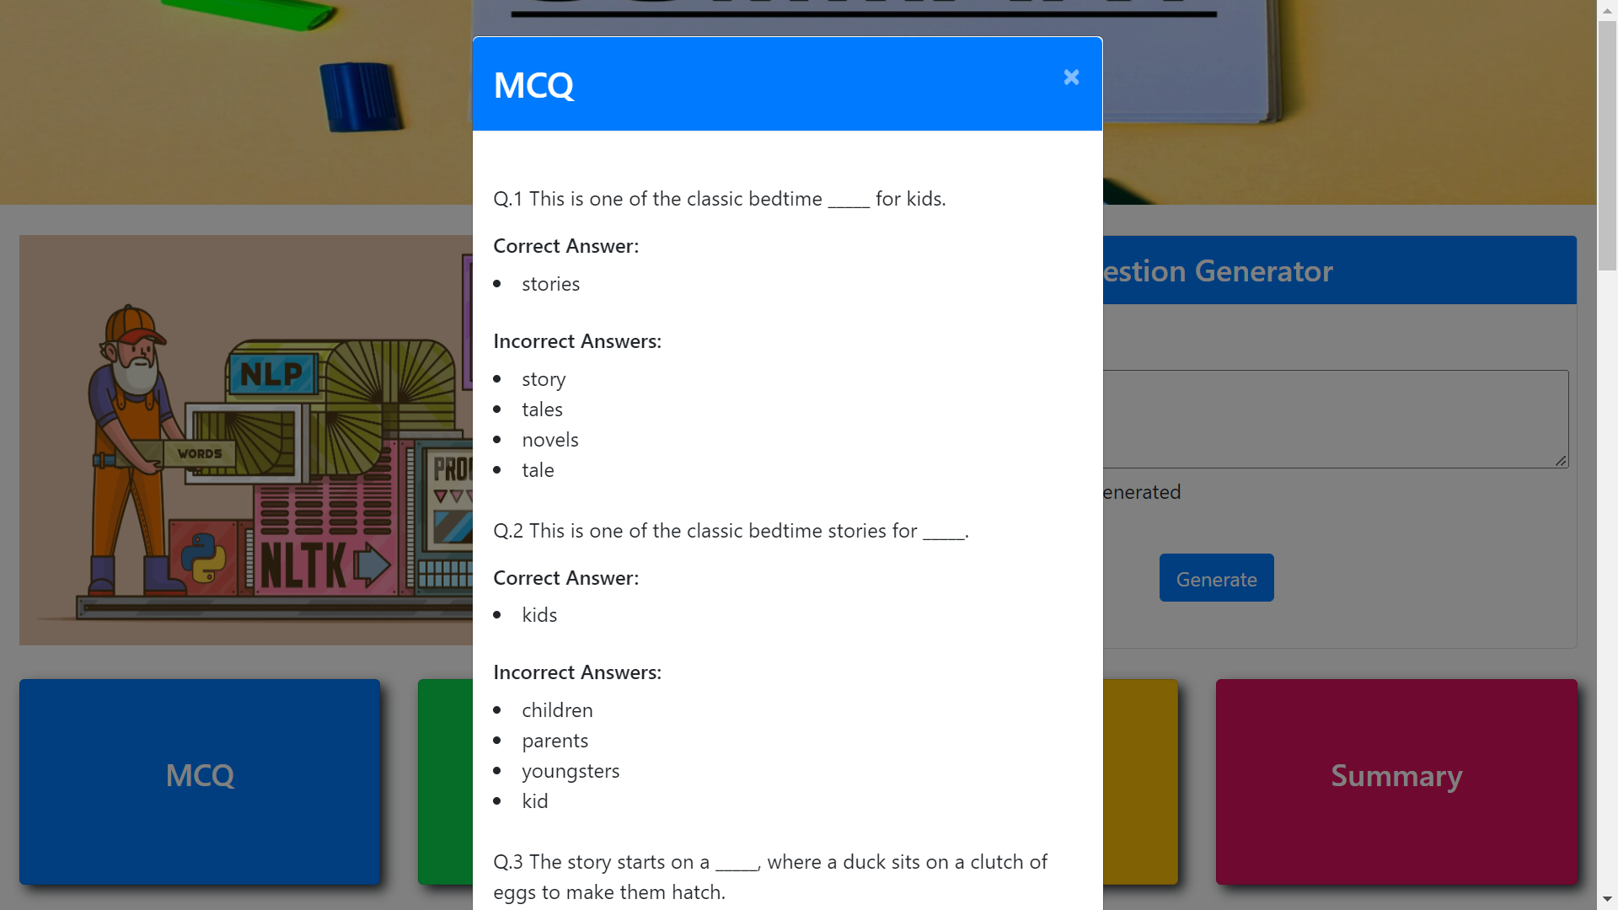

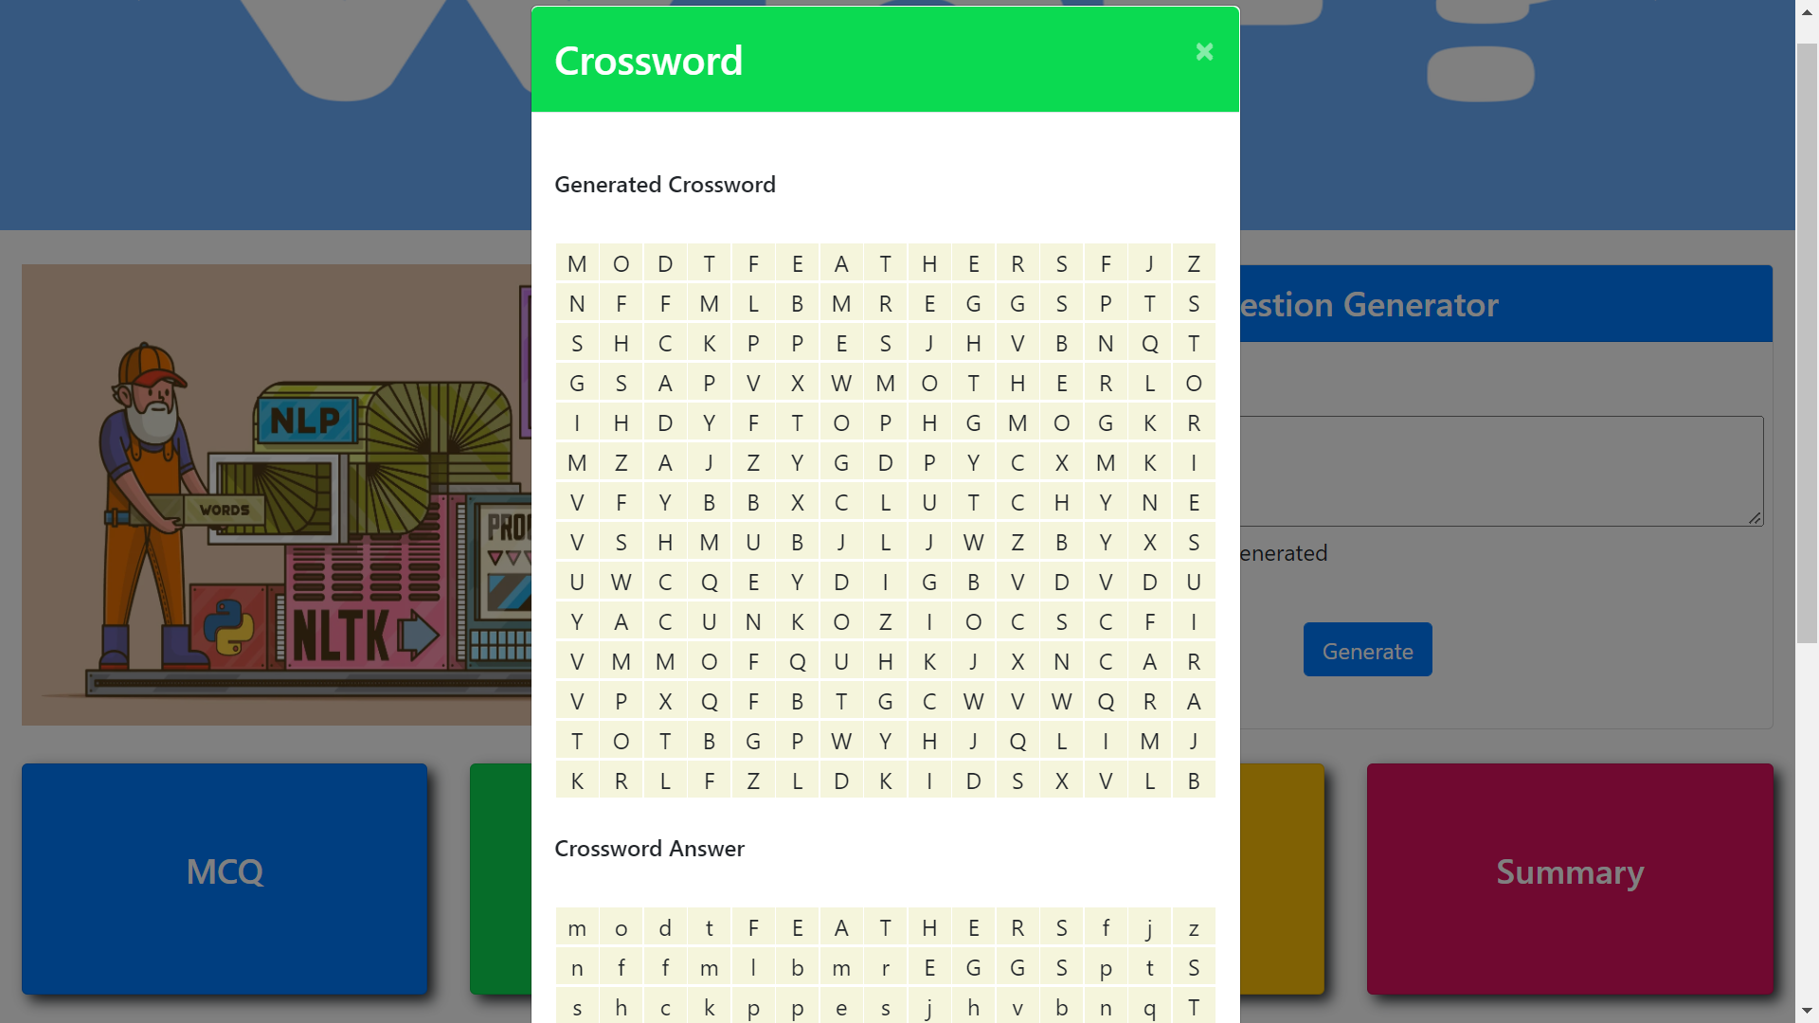

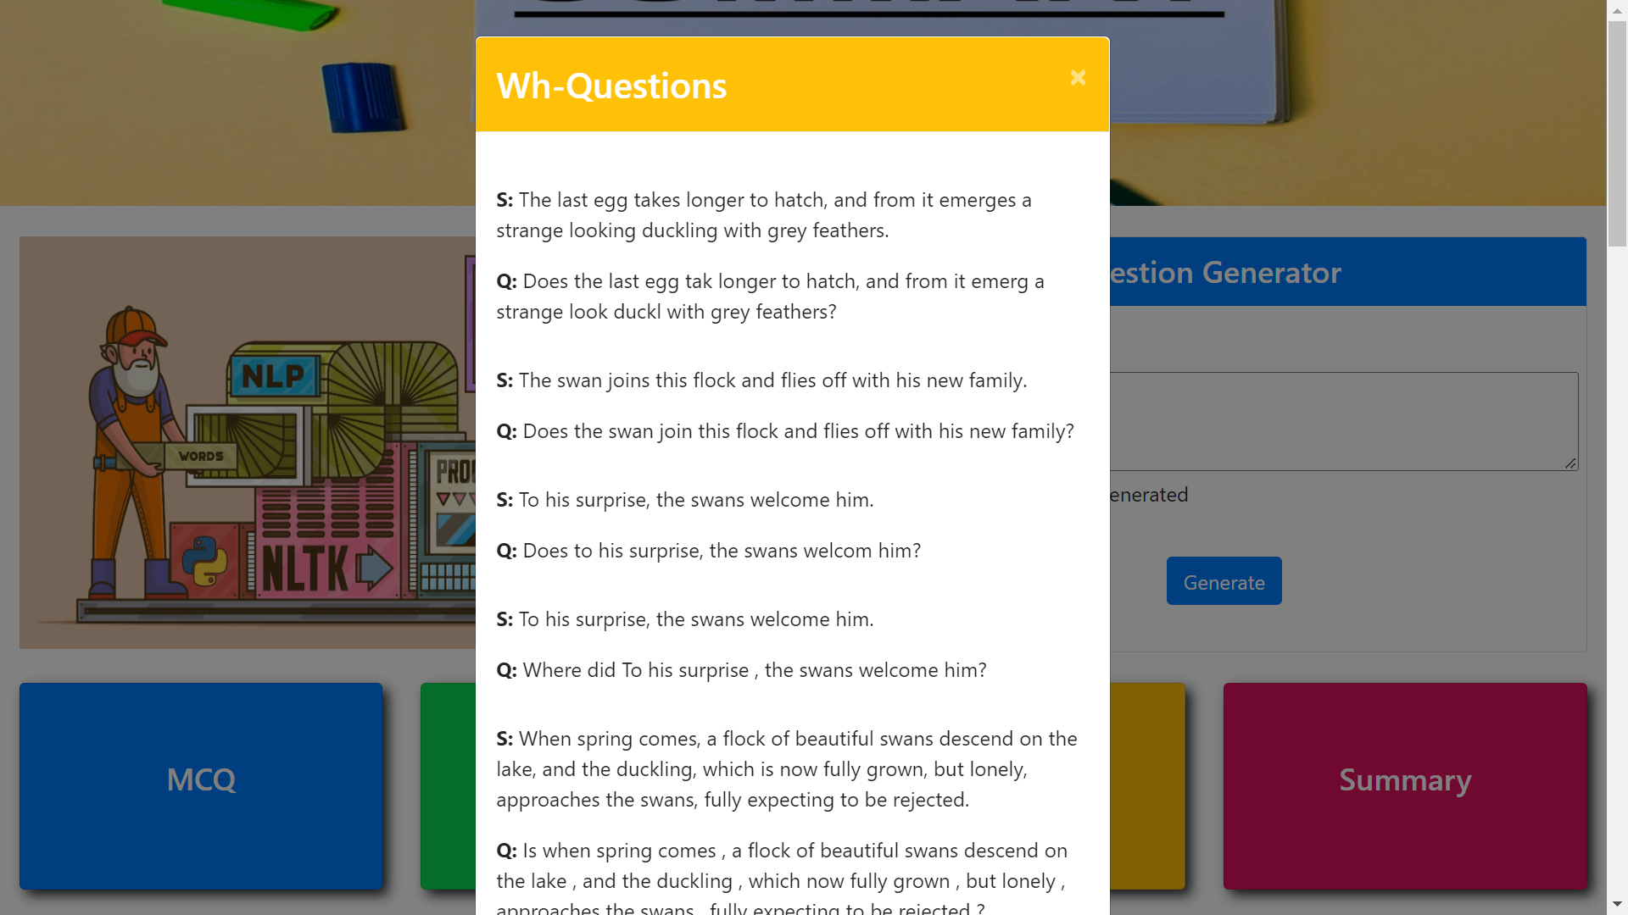

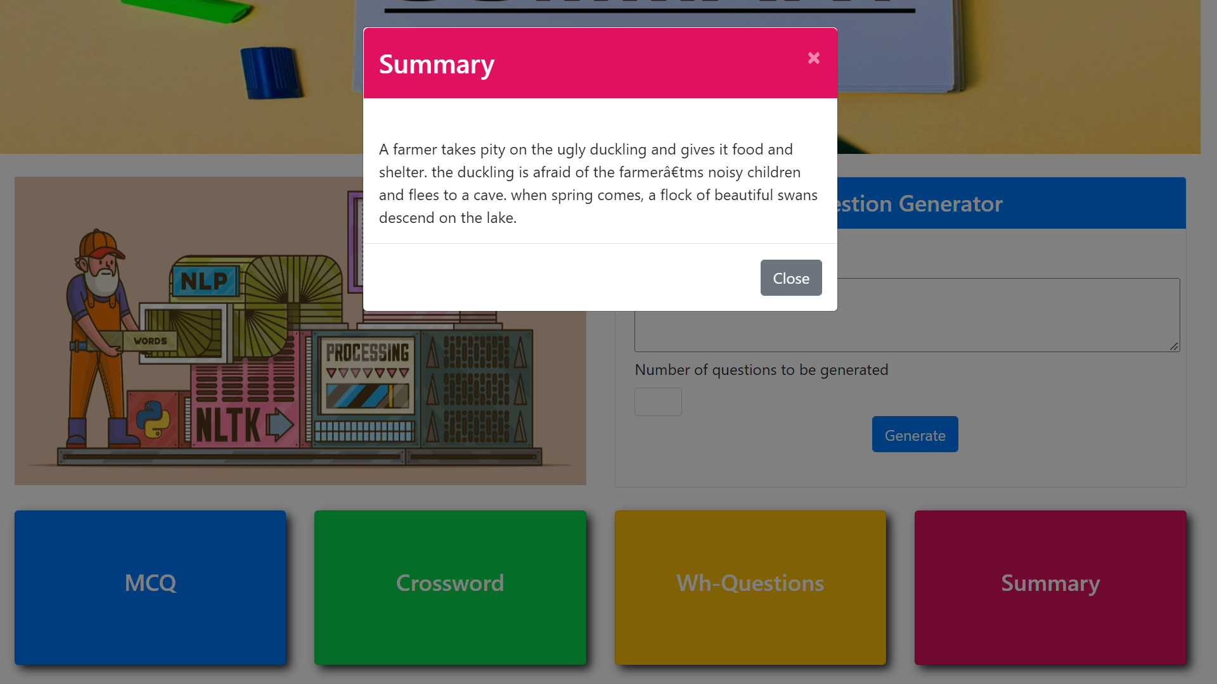

Fig 8: Results

###### CALCULATIONS AND DISCUSSIONS

We are using evaluation metrics such as MAE (Mean Absolute Error), MSE (Mean Squared Error), RMSE (Root Mean Squared Error) and R squared Value for evaluating all the 3 models.

1. Mean Absolute Error (MAE) is the average of difference between the actual data value and the predicted data value. It is calculated as shown below:

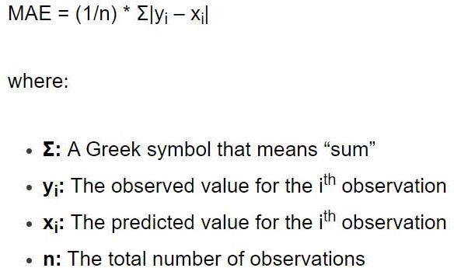

1. Mean Squared Error is the average squared difference between the estimated values and the actual value.

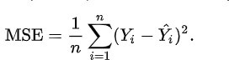

Where, n = Data set observations, Yi = Observation values, Y^i = Predicted Values .

1. Root Mean Squared Error is the root of MSE.

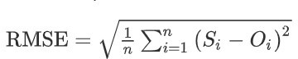

Where, n = Data set observations, Si = Predicted values, Oi = Observations.

1. R squared value is used for measuring the accuracy of the model.

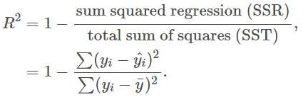

Where, R^2 = coefficient of determination.

Following are the values of evaluation metrics for the three models – Linear regression, Lasso regression and Ridge regression.

|  |  |  |  |  |  |
| --- | --- | --- | --- | --- | --- |
|  | MAE | MSE | RMSE | R Squared Value | Accuracy |
| Linear Regression | 12.4435 | 258.8112 | 16.7781 | 0.7598 | 75.98% |
| Ridge Regression | 12.1173 | 251.0317 | 15.8440 | 0.7447 | 74.47% |
| Lasso Regression | 12.2141 | 262.3797 | 16.1982 | 0.7409 | 74.09% |

Table 4: Values for Evaluation metrics

## CHAPTER 6 CONCLUSION AND FUTURE SCOPE

### CONCLUSION

We explored and applied several preprocessing steps and implemented various machine learning algorithms. Further we carried out a comparative study to understand the overall performance of the algorithms and select the most accurate and effective algorithm to implement. Automatic question generation and evaluation are becoming more prevalent in the intelligent education system as a result of developments in online learning. The paper begins with a compilation of review articles over the previous decade. Following that, it highlights the study progress by discussing state-of-the-art ways of diverse automatic question generation techniques by creating questions in the form of MCQ’s, fill in the blanks, WH questions, crosswords and summary. We generate MCQ’s and Fill in the blanks according to the user needs ie the number of questions demanded by the user. Crossword generated is dynamic and unique in nature as each user will have a different set of crossword for same set of input. Based on our research of the system, we can conclude that the system performs better when the input sentences are aggressive. With a few outliers, the overall quality of the created questions was good. For the input text, the algorithm was producing contextually relevant questions.

### FUTURE SCOPE

* + This approach can help the researchers fascinated towards automatic question generation to make the make more efficient and also to generate questions which are semantically and syntactically correct.
  + Professors can be relieved of the tedious task of making questions papers and instead they can use automatic question generation system to prepare question papers.
  + In future we would like to increase the efficiency of the model by training it with a larger dataset.
  + Also rather than using rule based approach for wh questions, the results may be better if neural networks are used to generate Wh-questions.
  + Furthermore, not all forms of Wh questions are generated, and criteria for those might be added to generate a wider range of questions.
  + Another way to improve the FIB model is to add some more extra features to the words, such as TF-IDF score, cosine-similarity to the title, and information on whether the pivotal response is present.

### REFERENCES

1. Putting the Horse Before the Cart: A Generator-Evaluator Framework for Question Generation from Text. Vishwajeet Kumar, Ganesh Ramakrishnan, and Yuan-Fang Li-Published: Sept 2019

2. Let’s Ask Again: Reﬁne Network for Automatic Question Generation - Preksha Nema, Akash Kumar Mohankumar, Mitesh M. Khapra, Balaji Vasan Srinivasan, Balaraman Ravindran - Published: 2019

3. Towards a Better Metric for Evaluating Question Generation Systems - Preksha Nema, Mitesh M. Kahpra - Published: 2018

4. A. Shirude, S. Totaia, S. Nikhar (Author), Dr. V. Attar (CoAuthor) and J. Ramanand (CoAuthor) - “Automated Question Generation Tool for Structured Data” - 2015 International Conference on Advances in Computing, Communications and Informatics (ICACCl)

5. Sumeet Pannu, Aishwarya Krishna, Shiwani Kumari, Rakesh Patra and Sujan Kumar Saha – “Automatic Generation of Fill in the Blank Questions from History Books for School-Level Evaluation” - Springer Nature Singapore 2018

6. Dhaval Swali1, Jay Palan2, Ishita Shah3– “Automatic Question Generation from Paragraph”- International Journal of Advanced Engineering and Research Development.

7. Blšták M., Rozinajová V. (2017) Machine Learning Approach to the Process of Question Generation. In: Ekštein K., Matoušek V. (eds) Text, Speech, and Dialogue. TSD 2017.

8. A System for Generating Multiple Choice Questions: With a Novel Approach for Sentence Selection10.18653/v1/W15-4410

9. Agarwal, M., Mannem, P.: Automatic Gap-fill Question Generation from Text Books. In: Proceedings of the Sixth Workshop on Innovative Use of NLP for Building Educational Applications, pp. 56–64 (2011)

10. Holy Lovenia, Felix Limanta, Agus Gunawan – “Automatic Question-Answer Pairs Generation from Text” -researchgate.net/publication/328916588(2018)

11. Akhil Killawala, Igor Khokhlov, Leon Reznik – “Computational Intelligence Framework for Automatic Quiz Question Generation” - 2018 IEEE

12.Vishwajeet Kumar1,3,4, Shivanand Muneeswaran2, Ganesh Ramakrishnan3, and Yuan-Fang Li4 – “Para QG: A System for Generating Questions and Answers from Paragraphs”.

[13]Pranav Rajpurkar ,JianZhang, Konstantin Lopyrev, and Percy Liang. (2016). Squad: 100, 000+ questions for machine comprehension of text. In Proceedings of the 2016 Conference on Empirical Methods in Natural Language Processing, EMNLP 2016, Austin, Texas,USA, November1-4,2016, pages 2383–2392

[14]https://nlp.stanford.edu/projects/glove/

[15]https://ai.googleblog.com/2020/02/exploring-transfer-learning-with-t5.html

## APPENDIX

**PAPERS PUBLISHED**

**International Journal for Research in Engineering Application & Management (IJREAM)**

***ISSN : 2454-9150* Vol-07, Issue-09, DEC 2021**

# Prediction of Final score in a Cricket Innings: A Survey

**1Abhishek Phalak , 2Shubhankar Yevale, 3Gaurav Muley, 4Prof. Shashikant Mahajan**

**1,2,3UG Student, 4Assistant Professor, Vidyalankar Institute of Technology, Mumbai, India, [1sidvijay83@gmail.com,](mailto:1sidvijay83@gmail.com) [2](mailto:2parakhrishabh123@gmail.com)[parakhrishabh123@gmail.com,](mailto:2parakhrishabh123@gmail.com) [3](mailto:3patilgaurav556@gmail.com)[patilgaurav556@gmail.com,](mailto:3patilgaurav556@gmail.com) [4shashikant0320@gmail.com](mailto:4shashikant0320@gmail.com)**

**Abstract- People have been passionately following sports such as cricket, football, badminton, tennis, ufc, Olympic events etc. all around the globe. A lot of people nowadays are keen to predict the final score or the winner of an ongoing sport event. Cricket is majorly played in three formats – Test, ODI and T20. This paper focuses on the Indian Premier League (IPL) which is conducted according to the T20 format of the game. It is often observed that the projected scores in an IPL T20 game are calculated using the Current Run Rate which is termed as the number of runs scored per over. But it is not an ideal overview of how an innings proceeds. Various dynamic instances within an over or two, can change the whole scenario of the innings. The aim of this survey paper is to present all the information and related works regarding the prediction of final score of an innings performed by various people. We will also look at what methodologies and machine learning algorithms they have used in order to achieve optimum accuracy for the same**.

***Keywords: Machine Learning, Regression, Prediction, Indian Premier League (IPL), Data Preprocessing****,* ***Data analytics*.**

* 1. **INTRODUCTION**

Cricket has an enormous fan base in India irrespective of whichever format it is played in. The T20 format of the game is the most celebrated one in recent years wherein both the teams get to bat as well as field for 20 overs and the team scoring more runs between the two is declared as the winner. After the introduction of Indian Premier League (IPL) in 2008, cricket has become a heavy sport accumulating investments of billion dollars as well as sponsorships from numerous popular brands in the country. The rise of IPL has fascinated a lot of people in predicting the outcomes of the IPL matches and the final score that the batting team will score in its 20 overs. One of the most luring investments in IPL months is an ever-increasing interest of the people in score prediction applications like Dream11, My11circle etc. These applications enable users to participate in certain contests upon paying the needed amount and then these applications reward the winners with cash prizes or gift coupons to those users who are successful in predicting the right outcome with respect to the contest requirements.

Usually, the calculation of the final score of the batting team in an innings is performed using the current run rate. That is a statistical method of calculating the final score. But numerous factors can change the course of the innings. Batting team scoring some quick runs by explosive batting or the bowling team taking back-to-back wickets and demoralizing the tendency of the batting team are some factors that are not considered while predicting the score using current run rate method. The runs scored by the batting

team and the wickets fallen at any instantaneous moment in an innings helps us get only an initial idea about the tendency in which the innings proceeds. The reason behind selecting these factors is to build one model that can understand the dynamicity of the cricket game. Therefore, we are considering the factors which will be focusing on the dynamic changes that happen gradually in a T20 innings. The uncertainty of these factors makes data analytics followed by application of machine learning as an appropriate method for finding the solution to the above-mentioned shortcoming. In this paper, we focus on the information and other related research works available regarding the considered subject matter and thus plan on building a more accurate model that will overrule the flaw reviewed in other works.

* 1. **LITERATURE SURVEY**

Vilas Rathod and Shreyan Jain in [1] have put forward a system that displays the live updates for football and cricket matches. The authors have used cricbuzz and ESPN APIs as source of information for cricket and football respectively. They aim to make it feasible for the user to see all the live updates of cricket as well as football on the same application so that there might not be a need to install various other applications and browse different websites separately. Their proposed work is created using Java and client communication is connected through the tomcat Apache server. The system requires the user to fill the current input hence it is following a holistic approach.

**International Journal for Research in Engineering Application & Management (IJREAM)**

***ISSN : 2454-9150* Vol-07, Issue-09, DEC 2021**

Prasad Thorat, Vighnesh Budhivant and Yash Shahne in

[2] have introduced a system CricFirstpredictor that will help in predicting the final score of batting team in their innings of 20 overs. The authors’ focus is on the Indian Premier League – as they wish to model the most dynamic format of the cricket game i.e., the T20 format. They have taken the IPL dataset from Kaggle. After cleaning the dataset, they proceeded with one hot encoding method for data preprocessing. The three machine learning techniques performed in the paper are Linear regression, Random Forest regression and Lasso regression. They developed UI using Flask framework in order to present the results. On determining the accuracy of the three approaches after calculating the Mean absolute error, Mean Squared error and the Root Mean squared error; the authors reached to the conclusion that Linear regression was the most accurate of the three – having the highest accuracy (about 76%) for the prediction.

Tejinder Singh, Vishal Singla and Prateek Bhatia in [3] aim to predict the score of both the innings of a One-day international cricket match [ODI] and thus predict the winner. The dataset has been collected from espncricinfo website and possesses all the data of matches between 2002 to 2014 for eight teams as mentioned in the related work. Further the data has been analyzed in Weka where it is divided as the training dataset and the testing dataset. The authors have implemented Linear Regression Classifier for the first innings and the Naïve Bayer’s Classification for the second innings. The data of 5 overs span each from first to fifth over uptil 45th to 50th over has been attributed to both the playing teams for both the innings. Accuracy of Naïve Bayer’s classification starts from 68 percent at the initial stage of the innings increasing to 91 percent at the end of the innings.

D Thenmozi, P Mrinalini, SM Jaisakthi et al in [4] aim to predict the winner of an ongoing IPL match at any instantaneous moment of the event. The authors collected the dataset from the website [‘www.cricsheet.org’](http://www.cricsheet.org/) and have implemented machine learning algorithms such as ‘Gaussian Naive Bayes’, ‘Support Vector Machine’, ‘K-Nearest Neighbour’ and ‘Random Forest regression’. After filtering the data, they implement the Recursive feature elimination method in order to sort and select the features. Generated models were based on the phases: from 2-overs to 20-overs: in an ongoing match. They analyse the results by considering few factors such as – ‘the number of features selected’, ‘which phase of the match is inputted’, ‘which machine learning technique is used’ and ‘the team considered for prediction’ – and thereafter conclude that random forest regression provided the optimum accuracy for prediction. The overall accuracy in their model is 75.5%.

A N Wickramasinghe and Roshan D. Yapa in [5] focus on predicting the man of the match as well as the outcome of that particular cricket match. The authors extracted around

150000 tweets using R studio by accessing twitter API and segregated them into negative and positive ones. 3 models proposed for the prediction were – one based on tweets, the other based on natural parameters and the third based on both tweets and natural parameters. ‘Logistic Regression’, ‘Support Vector Machine’, ‘Random Forest’ and ‘Naïve Bayes’ were the methods used for classification and the logistic regression classifier was used to find out whether there is any relationship between being popular and being elected as the man of the match. They tested all the models using 10 cross validation and later evaluated them on Accuracy, Sensitivity, Specificity and Cohen’s kappa statistic. It was concluded mixed model provided the maximum accuracy of 89% while the natural parameter- based model was 83% accurate.

Aminul Islam Anik, Sakif yeaser, AG M Imam Hossain and Amitabha Chakrabarty in [6] propose a model to predict a player`s performance in an upcoming match by studying their past data. The authors focus on the players of Bangladesh National Cricket team and have collected the data from howstat and espncricinfo websites. They preprocessed the dataset and used Scikit-learn package in order to select 5 important features from it. Thereafter two methods used for feature selection were – ‘Recursive Feature Elimination’ and ‘Feature Selection Using Univariate Selection’. They eliminated uncertain features such as 4s and 6s hit by a batsman in an upcoming match which cannot be predicted. ‘Linear regression’, ‘Support Vector Machine (SVM) with Linear and Polynomial Kernel’ and ‘Processing text data with Bag of words concept’ were the three techniques used for predicting the performance of any selected player. The model provided up to the mark accuracy for all the players and the highest accuracy of about 92% was achieved while predicting Tamim Iqbal`s batting performance in his upcoming match.

Siyamalan Manivannan and Mogan Kaushik in [7] have put forward two approaches – one is feature encoding and the other is Convolutional Neural Network (CNN) for predicting the outcome of the cricket match. The author sets up his proposed approach with the baseline approach. They collected the data from espncricinfo website using the python wrapper. In this paper, data augmentation is applied to training and testing dataset and normalized the final feature vector before giving it to linear SVM classifier. The authors applied clustering method during the feature encoding approach and used the player-category similarity as a weighted distance measure in order to determine the team- category relationship. While applying the CNN they connected the input nodes and the hidden nodes followed by implementing the CNN property of weight sharing. The accuracy of the model was over 70 percent using shallow CNN by training just 4000 parameters.

Manuka Madhuranga Hatharasinghe and Guhanathan Poravi in [8] aim to use computer intelligence to predict

**International Journal for Research in Engineering Application & Management (IJREAM)**

***ISSN : 2454-9150* Vol-07, Issue-09, DEC 2021**

cricket match outcomes and are studying the related works for the same. This paper is a result of an ongoing research. The authors point out match stimulation, team selection and player performance analysis as the three main domains to improvise the accuracy for prediction. The two main approaches that they followed were the use of historical cricket data and the collective knowledge. In usage of historical data, classification using team and categorical data done by naïve Bayer’s algorithm gave the maximum accuracy. Moreover, they discussed the team composition approach that provided the highest accuracy by using the historical data. Analyzing the existing works by relating the data used to that of the raw features, engineering features and the categorical features helped the authors conclude that the collective knowledge approach provided an accuracy of whooping 87%.

Jalaz Kumar, Rajeev Kumar and Pushpender Kumar in [9] use Decision Trees and Multilayer Perceptron Network to analyze the outcome of a cricket match. The authors have considered various pre-game and in-game attributes for the same. The data has been extracted from EspnCricinfo website by running a scraping script in a justified manner sending requests at every second. After preprocessing the data, they applied Decision tree and Multilayer Percepton Network classification techniques to it. In MLP, all vectors comprising the training samples were held in X & the target values for respective training samples were held in Y. In Decision tree technique the subsets were split and they used the impurity function for determining impurity followed by partioning the subsets until the maximum allowable depth was reached. After analyzing all the factors that strive to affect the flow of a cricket game, they compare the simulation results such as accuracy value and precision value. That helped the authors to conclude that the Multilayer Perceptron Network approach was more accurate than Decision technique displaying an accuracy of 0.576 and

0.551 respectively.

Sunil Ray in [10] provides significant information about regression analysis and states it as technique that determines a relationship between dependent and independent variable. Thereafter the author states the benefits of the regression techniques and the three metrics that drive them – ‘number of dependant variables’, ‘shape of the regression line’ and ‘type of dependant variable’. Later, he explains the 7 regression techniques in detail which are Linear Regression, Logistic regression, Polynomial Regression, Stepwise Regression, Ridge Regression, Lasso Regression and ElasticNet Regression. He makes a point to focus that the regression technique to be implemented should be selected by considering the conditions of data.

* 1. **CONCLUSION**

After going through all the related works and information, one can conclude that the outcome and final score predictions for Cricket matches remains an exciting and promising area

for research. T20 format is proven to be the best suitable cricketing format to model a game because many T20 leagues are played throughout the year. But achieving an optimum accuracy for predicting the exact range for the final score in a T20 innings remains a challenging task due to the fast-changing dynamics of the game. Moreover, one can conclude that it is impossible to predict the final score of an innings in a cricket match without analyzing the provided data thereafter applying machine learning techniques to it. A particular methodology or an algorithm cannot be pointed out as the best way to go about the process for achieving an accurate prediction as numerous parameters such as – which dataset is being used, how minute is the information in it, how are you preprocessing it, what attributes are being taken into consideration etc. play a vital role. Hence it is advised to perform the algorithm which provides you an optimum accuracy according to the chosen dataset. A keen point to notice – the more the number of attributes and schema in the dataset, more is the accuracy of the implementing model.

**REFERENCES**

1. Vilas Rathod, Sheyann Jain. “Live Score of Sports”. Issued February 2018. DOI 10.17148/IJARCCE.2018.7245.
2. Prasad Thorat, Vighnesh Budhivant, Yash Shahne. “Cricket Score Prediction”. Issued May 2021. [www.IJCRT.Org](http://www.IJCRT.Org/)
3. Tejiender Singh, Vishal Singhla, Prateek Bhatia. “Score and winning prediction in cricket through data mining”. Accessed November 2021. DOI 10.1109/ICSCTI.2015.7489605.
4. D Thenmozi, P Mirunalini, S M Jaisakhti et al. Moneyball – “Data mining on cricket dataset”. Issued October 2019. DOI 10.1109/ICCIDS.8862065.
5. A. N Wickramasinghe, Roshan D. Yapa. “Cricket Match Outcome Prediction Using Tweets and Prediction of the Man of the Match using Social Network Analysis: Case Study Using IPL Data”. Accessed November 2021. DOI 10.1109/ICTER.2018.8615563.
6. Aminul Islam Anik, Sakif Yeaser, A.G.M Imam Hossain, Amitabha Chakrabarty. “Player’s Performance Prediction in ODI Cricket Using Machine Learning Algorithms”. Issued January 2019. DOI 10.1109/CEEICT.2018.8628118.
7. Siyamalan Vanimannan, Mogan Kausik. “Convolutional Neural Network and Feature Encoding for Predicting the Outcome of Cricket Matches”. Accessed November 2021. DOI 10.1109/ICIIIS47346.2019.9063316.
8. Manuka Maduranga Hatharasinghe, Guhanathan Poravi. “Data Mining and Machine Learning in Cricket Match Outcome Prediction: Missing Links”. Issued March 2020. DOI 10.1109/I2CT45611.2019.9033698.
9. Jalaz Kumar, Rajeev Kumar, Pushpender Kumar. “Outcome Prediction of ODI Cricket Matches using Decision Trees and MLP Networks”. Accessed November 2021. DOI 10.1109/ICSCCC.2018.8703301
10. Analytics Vidhya. “7 Regression techniques you should know”. Accessed November 2021.

https://[www.analyticsvidhya.com/blog/2015/08/comprehensiv](http://www.analyticsvidhya.com/blog/2015/08/comprehensiv) e-guide-regression/

**International Journal for Research in Engineering Application & Management (IJREAM)**

***ISSN : 2454-9150* Vol-07, Issue-09, DEC 2021**

# Final Score Prediction of an Innings using Machine Learning

**1Abhishek Phalak , 2Shubhankar Yevale, 3Gaurav Muley, 4Prof. Shashikant Mahajan**

**1,2,3UG Student, 4Assistant Professor, Vidyalankar Institute of Technology, Mumbai, India, [1sidvijay83@gmail.com,](mailto:1sidvijay83@gmail.com) [2parakhrishabh123@gmail.com,](mailto:2parakhrishabh123@gmail.com) [3patilgaurav556@gmail.com,](mailto:3patilgaurav556@gmail.com) [4shashikant0320@gmail.com](mailto:4shashikant0320@gmail.com)**

**Abstract- The most followed and celebrated events around the globe today are sport events which include Football, Cricket, UFC, Formula1, Baseball, Basketball and many more. This paper focuses on a sport called Cricket which is played primarily in 3 formats – The test format, the ODI format and the T20 format. T20 is the shortest as well as the most dynamic format of the game and many T20 leagues are played throughout the year. We are considering the teams of Indian premier League (IPL) for predicting the final score of a batting team in their quota of 20 overs. It is often observed that the projected scores in an IPL T20 game are calculated using the Current Run Rate which is termed as the number of runs scored per over. But it is not an ideal overview of how an innings proceeds. Various dynamic instances within an over or two, can change the whole scenario of the innings. We aim to create a model that can consider the dynamicity of the game and can predict the final score by providing optimum accuracy**.



***Keywords* —*Data preprocessing, Machine Learning, Data splitting, Regression, Indian Premier League (IPL), Prediction***

* 1. **INTRODUCTION**

In a T20 format of cricket game, both the teams get to bat as well as field for 20 overs and the team scoring more runs between the two is declared as the winner. Introduction of the Indian Premier League (IPL) in 2008 has made Cricket a heavy sport by attracting various popular brands to provide sponsorship in exchange to their publicity. Billions are invested while conducting and celebrating the league. Nowadays people not only are excited to follow their favorite teams on matchdays but also are keen to predict the final score and the winner of an ongoing match. This observation has led to many luring investments in fantasy applications which enable users to participate in certain contests upon paying the needed amount. The ones who are successful in predicting the right outcome as per the contest requirements are then presented with cash rewards and gift coupons.

We have gone through various other systems that predict the final scores and outcomes of a cricket match and we can observe that the projected scores of a team are calculated using the Current Run rate. That is a statistical method of calculating the final score. But numerous factors can change the scenario of an innings. Batting team scoring some quick runs by explosive batting or the bowling team taking back- to-back wickets and demoralizing the tendency of the batting team are some factors that are not considered while predicting the score using current run rate method. The runs scored by the batting team and the wickets fallen at any

instantaneous moment in an innings helps us get only an initial idea about the tendency in which the innings proceeds. Hence, we look forward to propose a model that will consider the tendency and gradual changes that happen as the innings proceeds. We have analyzed and reviewed the related works on cricket score prediction below and later discussed the methodology, implementation and results of our model.[1]

* 1. **LITERATURE SURVEY**

We analyzed and studied some related works based on the domain of our paper i.e., cricket score prediction. The inferences of all the 9 papers that have been studied are described below.

Vilas Rathod and Shreyan Jain in [2] have used Java and Apache Server to propose a system that collects information from Cricbuzz and ESPN APIs to display the live updates for football and cricket matches. Prasad Thorat, Vignesh Budhivant and Yash Shahne in [3] have introduced a system that uses Linear regression, Random Forest regression and Lasso regression to predict the final score of an innings and later display the result on a webpage developed using ‘Flask’. Tejinder Singh, Vishal Singla and Prateek Bhatia in

[4] predict the outcome of an ODI cricket match by analysing the data on ‘Weka’ and using the Linear regression classifier and Naïve Bayes Classification. D Thenmozi, P Mrinalini, SM Jaisakthi et al in [5] predict the winner of an ongoing IPL match at any instantaneous moment by selecting features using recursive feature

**International Journal for Research in Engineering Application & Management (IJREAM)**

***ISSN : 2454-9150* Vol-07, Issue-09, DEC 2021**

elimination and then apply machine learning algorithms such as ‘Gaussian Naive Bayes’, ‘Support Vector Machine’, ‘K-Nearest Neighbour’ and ‘Random Forest regression’. A N Wickramasinghe and Roshan D. Yapa in [6] implement ‘Logistic Regression’, ‘Support Vector Machine’, ‘Random Forest’ and ‘Naïve Bayes’ on dataset possessing 150000 tweets extracted from twitter API using R to predict the outcome and the man of the match for a cricket game. The authors implement sentimental analysis on the extracted tweets dividing them into positive and negative ones. Aminul Islam Aniak, Sakif yeaser, AG M Imam Hossain and Amitabha Chakrabarty in [7] propose a model that predicts the selected player`s performance in an upcoming match by feature selection process and thereafter applying classification techniques like ‘Linear regression’, ‘Support Vector Machine (SVM) with Linear and Polynomial Kernel’ and ‘Processing text data with Bag of words concept’. They have considered the players of Bangladesh National Cricket team for the same. Siyamalan Manivannan and Mogan Kaushik in [8] predict the outcome of a cricket match using two methods – one is feature encoding and the other is Convolutional Neural Network (CNN). Manuka Madhuranga Hatharasinghe and Guhanathan Poravi in [9] study the related works for predicting the outcome of a cricket match using computer intelligence and conclude that the ‘use of historical data’ and ‘collective knowledge’ are two vital approaches for the same. Jalaz Kumar, Rajeev Kumar and Pushpender Kumar in [10] extract data from EspnCricinfo website and implement Decision Trees and Multilayer Perceptron Network to analyze the outcome of a cricket match. They have focused on various pre-game and in-game attributes for the same.

* 1. **PROPOSED SYSTEM**

We are proposing a system that helps the user to predict a range of final score i.e., from lower bound to upper bound by achieving optimum accuracy. Firstly, the user needs to fill the input fields provided on the webpage. The input fields require basic details of the innings that include the Batting team and the Fielding team. Then he/she needs to provide the current score of the ongoing match that includes the number of runs scored, the number of overs bowled and the number of wickets fallen - at that particular instance. Lastly the user should input the dynamic factors – the runs scored in last 5 overs and the wickets taken in the last 5 overs - that will reflect the dynamic changes and the tendency shift of the innings. Upon providing all the input fields, the system enables the user to predict the final score.

* 1. **METHODOLOGY**

Following steps were performed while building the system.

**Data Collection:** The dataset has been extracted from Kaggle. It possesses data of over-to-over right from the commencement of IPL in 2008 upto the end of season 2017.

It’s an enormous dataset of 76015 rows and 15 columns (each representing one attribute).

**Data Cleaning:** From the selected dataset, some teams have not played all the seasons of the IPL and are not playing the upcoming season too. Therefore, data of inconsistent teams such as Deccan Chargers, Kochi Tuskers Kerala, Rising Pune supergiants, Gujarat Lions, Pune Warriors India etc. has not been considered for the prediction. Moreover, we have removed few unwanted columns from the dataset as they will not be useful for prediction. As we have considered attributes such as “wickets taken in last 5 overs” and “runs scored in last 5 overs”, we have removed the data of first 5 overs of every inning. We have converted the ‘date’ column to date-time object from string format thus making it suitable for use. The attributes that will be used for prediction are described below.

|  |  |
| --- | --- |
| Attributes | Descriptions |
| Bat_team | The team which is batting |
| Bowl_team | The team which is fielding |
| Runs | Runs scored by the batting team at that particular instance |
| Wickets | Wickets lost by the batting team at that particular instance |
| Overs | Overs bowled by the bowling team at that particular instance |
| Runs_last_5 | Runs scored by the batting team in immediate previous 5 overs from the current instance |
| Wickets_last_5 | Wickets taken by the bowling team in immediate previous 5 overs from the current instance |

**Table 1: Description of the attributes**

**Data Preprocessing:** While preprocessing the data, we have implemented the ‘One hot encoding’ method. It is a process of converting the categorical data variables into numerical values thus making it suitable to use while implementing machine learning algorithms. Thereafter we rearranged all the columns of the dataset.

**Data Splitting:** Data was split into training and testing dataset where the data of the teams before year 2016 was considered for training the model and the data after 2016 was considered as the testing data.

**Generating the model:** The models have been generated using the Linear regression, Ridge regression and Lasso Regression. The model that provides the highest accuracy will be considered for prediction.

**Presenting the Final prediction:** The user inputs will be taken from the end user and the data will be passed to the model which will lead to the prediction of final score from lower bound to upper bound. score.

**International Journal for Research in Engineering Application & Management (IJREAM)**

***ISSN : 2454-9150* Vol-07, Issue-09, DEC 2021**

* **Models:**
  1. **IMPLEMENTATION**

**Fig 1: System Methodology Flowchart**

linearity, independence and constant variation. [11]

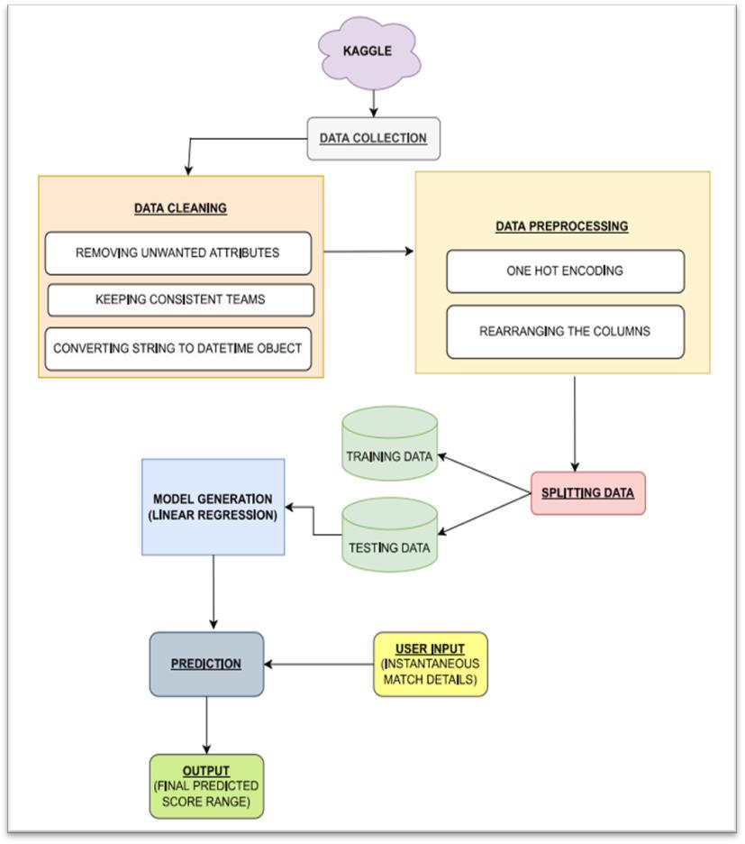

c) Lasso Regression:

* + 1. Linear Regression:

Linear Regression is a Supervised Machine learning algorithm that takes the help of historical data for prediction. It helps the user to determine the relationship between the dependent and the independent variable. In the case of this project, value of the final score is the dependent variable(y) and the input factors used for prediction are the independent variables(x). The equation for Linear Regression is in the form

Y = a + bX where Y is the dependent variable and X is the explanatory i.e., the independent variable.

* + 1. Ridge Regression:

Ridge regression is used for those models where the data suffers from multicollinearity. It is used as a shrinkage operator that reduces model complexity by shrinking the coefficient. The main assumptions of Ridge regression are

Lasso regression is a regularization technique which is used for a more accurate prediction. The word “LASSO” stands for **L**east **A**bsolute **S**hrinkage and **S**election **O**perator. Lasso regression is uses shrinkage and is suitable for models wherein methods of parameter elimination of variable selection are used. [12]

* **UI development:**

In this project, Flask framework has been used for the UI development. The main web page of the project takes the required inputs from the user in order to predict the final score. The user inputs required are Batting team, bowling team, runs scored at that current instance, overs bowled at the current instance, number of wickets at the present instance, number of runs scored in the last 5 overs and and number of wickets taken in the last 5 overs. After inputting all the fields, the user will click the “predict score” button and then the form is submitted. Model enters the scenario at

**International Journal for Research in Engineering Application & Management (IJREAM)**

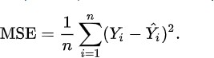***ISSN : 2454-9150* Vol-07, Issue-09, DEC 2021**

the backend after the submission of the form. The inputs take the help of the historical data and are analysed through supervised machine learning techniques resulting in the prediction of final score. The routing of the pages is done based on the URLs. When the browser finds the ‘/’ in the URL it redirects the user to the home page. After the submission of the form, the user is redirected to the '/result' URL i.e., to the result page where we can see the final result i.e., the prediction.

* 1. **RESULTS**

We are using evaluation metrics such as MAE (Mean Absolute Error), MSE (Mean Squared Error), RMSE (Root Mean Squared Error) and R squared Value for evaluating all the 3 models.

* Mean Absolute Error (MAE) is the average of difference between the actual data value and the predicted data value. It is calculated as shown below:

Where, n = Data set observations Yi = Observation values

Y^i = Predicted Values [14]

* 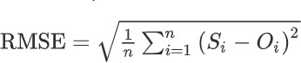Root Mean Squared Error is the root of MSE.

Where, n = Data set observations Si = Predicted values

Oi = Observations [15]

* R squared value is used for measuring the accuracy of the model.

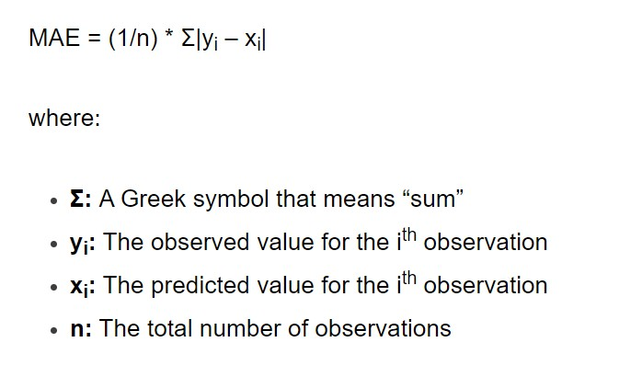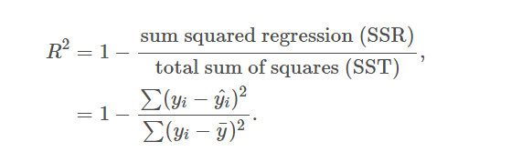

[13]

* Mean Squared Error is the average squared difference between the estimated values and the actual value.

Where,

R^2 = coefficient of determination [16]

Following are the values of evaluation metrics for the three models – Linear regression, Lasso regression and Ridge regression.

|  |  |  |  |  |  |
| --- | --- | --- | --- | --- | --- |
|  | **MAE** | **MSE** | **RMSE** | **R Squared Value** | **Accuracy** |
| **Linear Regression** | 12.4435 | 258.8112 | 16.7781 | 0.7598 | 75.98% |
| **Ridge Regression** | 12.1173 | 251.0317 | 15.8440 | 0.7447 | 74.47% |
| **Lasso Regression** | 12.2141 | 262.3797 | 16.1982 | 0.7409 | 74.09% |

**Table 2: Values for evaluation metrics**

* 1. **CONCLUSION AND FUTURE SCOPE**

We studied and applied three regression techniques in this project. From the results, we can conclude that Linear regression is providing us the highest accuracy. Therefore, we will consider the linear regression as the prediction model for the project.

This approach can help the players as well as the management staff for making strategical decisions and selecting the appropriate team combination for the upcoming match. Cricket lovers who participate in various award-winning contests related to the prediction of the match outcomes can find this system very helpful. This methodology can not only be applied on vast datasets but

also developed on bigger interfaces ahead for applications like dream11, my11circle etc. to use them and increase their brand values. Various other crucial factors like the venue, weather and pitch behavior can be considered in future systems in order to replicate as well as understand the real match scenario and thus get near-to-accurate prediction.

**REFERENCES**

1. Abhishek Phalak , Shubhankar Yevale, Gaurav Muley, Shashikant Mahajan. “Prediction of Final score in a Cricket Innings: A Survey”. Issued December 2021. DOI: 10.35291/2454-9150.2021.0605

**International Journal for Research in Engineering Application & Management (IJREAM)**

***ISSN : 2454-9150* Vol-07, Issue-09, DEC 2021**

1. Vilas Rathod, Sheyann Jain. “Live Score of Sports”. Issued February 2018. DOI 10.17148/IJARCCE.2018.7245.
2. Prasad Thorat, Vignesh Budhivant, Yash Shahne. “Cricket Score Prediction”. Issued May 2021. [www.IJCRT.Org](http://www.ijcrt.org/)
3. Tejinder Singh, Vishal Singhla, Prateek Bhatia. “Score and winning prediction in cricket through data mining”. Accessed December 2021. DOI 10.1109/ICSCTI.2015.7489605.
4. D Thenmozi, P Mirunalini, S M Jaisakhti et al. Moneyball – “Data mining on cricket dataset”. Issued October 2019. DOI 10.1109/ICCIDS.8862065.
5. A. N Wickramasinghe, Roshan D. Yapa. “Cricket Match Outcome Prediction Using Tweets and Prediction of the Man of the Match using Social Network Analysis: Case Study Using IPL Data”. Accessed December 2021. DOI 10.1109/ICTER.2018.8615563.
6. Aminul Islam Anik, Sakif Yeaser, A.G.M Imam Hossain, Amitabha Chakrabarty. “Player’s Performance Prediction in ODI Cricket Using Machine Learning Algorithms”. Issued January 2019. DOI 10.1109/CEEICT.2018.8628118.
7. Siyamalan Vanimannan, Mogan Kausik. “Convolutional Neural Network and Feature Encoding for Predicting the Outcome of Cricket Matches”. Accessed December 2021. DOI 10.1109/ICIIIS47346.2019.9063316.
8. Manuka Maduranga Hatharasinghe, Guhanathan Poravi. “Data Mining and Machine Learning in Cricket Match Outcome Prediction: Missing Links”. Issued March 2020. DOI 10.1109/I2CT45611.2019.9033698.
9. Jalaz Kumar, Rajeev Kumar, Pushpender Kumar. “Outcome Prediction of ODI Cricket Matches using Decision Trees and MLP Networks”. Accessed December 2021. DOI 10.1109/ICSCCC.2018.8703301
10. [https://www.mygreatlearning.com/blog/what-is-ridge- regression/](https://www.mygreatlearning.com/blog/what-is-ridge-regression/)
11. [https://www.mygreatlearning.com/blog/understanding- of-lasso-regression/](https://www.mygreatlearning.com/blog/understanding-of-lasso-regression/)
12. <https://www.statology.org/mean-absolute-error-python/>
13. <https://en.wikipedia.org/wiki/Mean_squared_error>
14. [https://www.sciencedirect.com/topics/engineering/root- mean-squared-error/](https://www.sciencedirect.com/topics/engineering/root-mean-squared-error/)
15. [https://www.ncl.ac.uk/webtemplate/ask- assets/external/maths-resources/statistics/regression-and- correlation/coefficient-of-determination-r-squared.htmln](https://www.ncl.ac.uk/webtemplate/ask-assets/external/maths-resources/statistics/regression-and-correlation/coefficient-of-determination-r-squared.htmln)

**CERTIFICATES : FINAL SCORE PREDICTION OF AN INNINGS USING MACHINE LEARNING**

**(IMPLEMENTATION PAPER**)



This is to Certify that Paper ID : IJREAMV07I0981024



*finakscore Predictiaw of aw Innings using*

*Machine* £enrninQ

Authored By

has been published in Volume 07, Issue 09, Dec 2021.

The mentioned paper has gone through Peer Review Process & measured

upto the required standard.



IJREAM

'

Editor, IJREAM

••‹

/OuMl%

' in Engineering Application & Manager

1

This is to Certify that Paper ID : IJREAMV07I0981024



*’finaCScove Prediction of an Innings using*



Authored By

has been published in Volume 07, Issue 09, Dec 2021.

The mentioned paper has gone through Peer Review Process & measured

upto the required standard.





IJREAM

' Editor IJREAM " ”‘

*I ’ Certificate Na. 245491502 I t3 978S*

in Engineering Application & Managem

[http://www.ijream.oigqpg](http://www.ijream.oigqpg/)

1





This is to Certify that Paper ID : IJREAMV07I0981024

ocfiinezeorwtw

Authored By

has been published in Volume 07, Issue 09, Dec 2021.

The mentioned paper has gone through Peer Review Process & measured

upto the required standard.



This is to Certify that Paper ID : IJREAMV07I0981024

*finaCScore Prediction of an Innings using*

Authored By

has been published in Volume 07, Issue 09, Dec 2021.

The mentioned paper has gone through Peer Review Process & measured upto the required standard.

#### CERTIFICATES:PREDICTION OF FINAL SCORE IN A CRICKET INNINGS : A SURVEY

**(REVIEW PAPER**)

This is to Certify that Paper ID : IJREAMV07I0981004



Prediction of;finakscore in a Cricket

facings.’ H Scxxe y

Authored By

has been published in Volume 07, Issue 09, Dec 2021.

The mentioned paper has gone through Peer Review Process & measured

upto the required standard.

Editor, IJREAM

1.1 REAM

International Journal for Research

in Engineering Application & Managem http //www ij org

This is to Certify that Paper ID : IJREAMV07I0981004



Prediction of;finakscore in a Cricket

facings.’ H Scxxe y

Authored By

has been published in Volume 07, Issue 09, Dec 2021.

The mentioned paper has gone through Peer Review Process & measured

upto the required standard.

This is to Certify that Paper ID : IJREAMV07I0981004



Prediction of;finakscore in a Cricket

facings.’ H Scxxe y

Authored By

has been published in Volume 07, Issue 09, Dec 2021.

The mentioned paper has gone through Peer Review Process & measured

upto the required standard.

Editor, IJREAM

1.1 REAM

International Journal for Research

in Engineering Application & Managem http //www ij org

This is to Certify that Paper ID : IJREAMV07I0981004



Prediction of;finakscore in a Cricket

facings.’ H Scxxe y

Authored By

has been published in Volume 07, Issue 09, Dec 2021.

The mentioned paper has gone through Peer Review Process & measured

upto the required standard.